Regulation for Enforcement of the Basic Act on Disaster Management

(Prime Minister's Office Order No. 52 of September 21, 1962)

In order to implement the Basic Act on Disaster Management and based on the provisions of the Order for Enforcement of the Basic Act on Disaster Management, the Regulation for Enforcement of the Basic Act on Disaster Management is established as below.

(Proposal by District Residents)
Article 1 Persons who intend to jointly make a plan proposal pursuant to the provisions of Article 42-2, paragraph (2) of the Basic Act on Disaster Management (Act No. 223 of 1961; hereinafter referred to as "the Act") must submit to the municipal disaster management council a proposal describing the names and addresses of all its members (in the case of a corporation, the name and location of its main office) together with the following documents:
(i) draft of the district disaster management plan
(ii) document showing that the persons are qualified to make a plan proposal

(Form of a Sign concerning Traffic Bans or Restrictions for Disaster Reduction Drill)
Article 1-2 (1) The form of a sign set forth in Article 20-2, paragraph (1) of the Order for Enforcement of the Basic Act on Disaster Management (Cabinet Order No. 288 of 1962; hereinafter referred to as "the Order") is to be as set forth in the appended form 1.
(2) The place where a sign is put pursuant to the provisions of Article 20-2, paragraph (1) of the Order is to be in front of the zone or the road section where the road passage of pedestrians or vehicles is going to be banned or restricted and in the center or on the left side of the road (in the case of a road whose sidewalk and roadway are separated, the roadway side of the sidewalk) at necessary points within the zone or the road section.

(Standard as Specified by Cabinet Office Order Set Forth in Article 20-3, Item (i) of the Order)
Article 1-3 The standard as specified by Cabinet Office Order set forth in Article 20-3, item (i) of the Order is to ensure that no hindrance is caused to evacuation by the placement of an article, or by the article dropping, falling, or moving due to an earthquake, or due to other reasons related to a rooftop or any other part of a facility to be used to receive residents, visitors, and any other persons (referred to as "Residents, etc." in Article 1-8, item (ii)) (in the case of a designated emergency evacuation site which is a facility prescribed in (b) of the same item and located outside (referring to a safety zone prescribed in Article 20-3, item (ii) of the Order), the relevant part and the steps usable in evacuation to the relevant part, and any other route).

(Technical Standard as Specified by Cabinet Office Order Set Forth in Article 20-3, Item (ii), (a) of the Order)
Article 1-4 As the technical standard as specified by Cabinet Office Order set forth in Article 20-3, item (ii), (a) of the Order, the structure is to not cause any destruction, falling, sliding, or sinking, or any other situation that is detrimental to structural strength that arises due to a force acting on the facility generated by water pressure, wave pressure, vibration, shock, or other anticipated reasons caused by the relevant extraordinary phenomenon (if the relevant extraordinary phenomenon is a tsunami, conformity to the technical standard prescribed in the following Article is included).

(Technical Standard as Specified by Cabinet Office Order Set Forth in Article 20-3, item (iii), (a) of the Order)
Article 1-5 As the technical standard as specified by Cabinet Office Order set forth in Article 20-3, item (iii), (a) of the Order, the structure is to meet the Building Standards Act (Act No. 201 of 1950) concerning safety against earthquakes, as well as Orders and provisions of prefectural or municipal ordinances based on this Act.

(Kinds of Extraordinary Phenomena as Specified by Cabinet Office Order Set Forth in Article 20-4 of the Order)
Article 1-6 The kinds of extraordinary phenomena as specified by Cabinet Office Order set forth in Article 20-4 of the Order are flooding in cases where there is a sudden heavy rain and the relevant rain water cannot be drained in the sewerage system, any other drainage facilities, rivers, or any other public water areas, and pyroclastic flow, lava flow, cinder, and any other volcanic phenomena caused by volcanic eruption.

(Notification of Change)
Article 1-7 The notification of a change under Article 49-5 of the Act (including as applied mutatis mutandis pursuant to Article 49-7, paragraph (2) of the Act) is to be made by submitting a written notification describing the details of the relevant change.

(Public Notice of Designated Shelters)
Article 1-7-2 (1) When designated shelters that meet the standards specified in Article 20-6, items (i) through (iv) of the Order pursuant to the provisions of Article 49-4, paragraph (3) of the Act as applied mutatis mutandis pursuant to Article 49-7, paragraph (2) of the Act (excluding those meeting the standards specified in Article 20-6, items (i) through (v) of the Order; hereinafter referred to as "designated general shelters" in this paragraph) are designated, a public notice is to be made with regard to the names and locations of the designated general shelters and other matters found necessary by the mayor of a municipality.
(2) Beyond what is provided for in the preceding paragraph, when designated shelters that meet the standards specified in Article 20-6, items (i) through (v) of the Order pursuant to the provisions of Article 49-4, paragraph (3) of the Act as applied mutatis mutandis pursuant to Article 49-7, paragraph (2) of the Act (hereinafter referred to as "designated welfare shelters" in this paragraph) are designated, a public notice is to be made with regard to the names and locations of the designated welfare shelters, the fact that disaster victims, etc. to be accepted at these shelters are designated if such designation is made, and other matters found necessary by the mayor of a municipality.

(Necessary Measures to Fully Inform Residents of the Methods of Transmitting Information on Disaster)
Article 1-8 Necessary measures to fully inform residents, etc. set forth in Article 49-9 of the Act are to be as set forth below:
(i) each household will be provided with a plan indicating the area of land which is found likely to risk the lives or bodies of people when an extraordinary phenomenon occurs, and containing descriptions of matters prescribed in Article 49-9 of the Act (including records made by electronic methods, magnetic methods, and any other methods not recognized by the human senses) by distributing printed materials or any other proper method;
(ii) residents, etc. will be placed in a situation where they can receive the relevant information through the information set forth in the matters shown and indicated in the plan set forth in the preceding item, by the use of the Internet, or other appropriate methods.

(Standard as Specified by Cabinet Office Order Set Forth in Article 20-6 of the Order)
Article 1-9 The standard as specified by Cabinet Office Order set forth in Article 20-6 of the Order is to be as set forth below:
(i) measures are taken to ensure that the elderly, disabled persons, infants, and others requiring special care (hereinafter referred to as "persons requiring special care" in this Article) can use the facilities smoothly;
(ii) systems will be prepared to enable persons requiring special care to engage in consultation or receive advice or any other support when a disaster occurs;
(iii) as much as possible, necessary residential facilities will be secured where mainly persons requiring special care can stay when a disaster occurs.

(Report on Conditions of Disaster)
Article 2 (1) The report on the conditions of a disaster and the outline of the measures taken for the disaster under Article 21 of the Order is to be made based upon the occurrence of the disaster and periodically thereafter, and the final report is to be made within 20 days after the date of completion of emergency measures for the relevant disaster.
(2) The report on the degree of the damage prescribed in Article 21, item (iv) of the Order is to be made on the matters set forth in appended table 1 in the case of a report to be made by a municipality and prefecture pursuant to the provisions of Article 53, paragraphs (1) and (2) of the Act, on the estimated amount of the damage caused by the disaster in the case of a report to be made by the representative of a designated public corporation pursuant to the provisions of paragraph (3) of the same Article, and on the matters concerning the function under their jurisdiction out of the matters set forth in appended table 2 in the case of a report to be made by the head of a designated administrative organ pursuant to the provisions of paragraph (4) of the same Article.

(Office of Regional Coast Guard Headquarters as Specified by Cabinet Office Order Set Forth in Article 23 of the Order)
Article 2-2 The office of regional coast guard headquarters set forth in Article 23 of the Order is to be coast guard offices, air stations, and coast guard stations.

(Persons Designated by Cabinet Office Order Set Forth in Article 61-4, Paragraph (4) of the Act)
Article 2-3 (1) The persons designated by Cabinet Office Order set forth in Article 61-4, paragraph (4) of the Act are to be the following: the person that manages the evacuation site to accept people in need of evacuation set forth in the same paragraph; the head of a relevant designated local administrative organ; relevant designated public corporations and designated local public corporations; relevant public organizations; and any other persons found necessary by the consulted mayor set forth in the same paragraph.
(2) The persons designated by Cabinet Office Order set forth in Article 61-4, paragraph (6) of the Act are to be the following: the person that manages an evacuation site which actually accepted people in need of evacuation in the area of the municipality under the control of the consulting mayor set forth in the same paragraph when the consulting mayor received the notification set forth in the same paragraph; the head of a relevant designated local administrative organ; relevant designated public corporations and relevant designated local public corporations; relevant public organizations; and any other persons found necessary by the consulting mayor.
(3) The provisions of paragraph (1) apply mutatis mutandis to the persons designated by Cabinet Office Order set forth in Article 61-5, paragraph (6) and Article 61-6, paragraph (5) of the Act. In this case, the term "consulted mayor" in paragraph (1) is deemed to be replaced with "consulted mayor outside the prefecture."
(4) The provisions of paragraph (2) apply mutatis mutandis to the persons designated by Cabinet Office Order set forth in Article 61-5, paragraph (10) and Article 61-6, paragraph (7) of the Act.

(Office of Regional Coast Guard Headquarters as Specified by Cabinet Office Order Set Forth in Article 24 of the Order)
Article 2-4 The office of regional coast guard headquarters set forth in Article 24 of the Order is to be coast guard offices, air stations and coast guard stations.

(Commanding Officers of Units as Specified by Cabinet Office Order Set Forth in Article 24 of the Order)
Article 3 The commanding officers of units prescribed in Article 8 of the Self-Defense Forces Act (Act No. 165 of 1954) set forth in Article 24 of the Order are to be as set forth below:
(i) Commanding General of Army, Ground Self-Defense Force
(ii) Division Commanding General of Army, Ground Self-Defense Force
(iii) Brigade Commanding General of Army, Ground Self-Defense Force
(iv) commanding officers of units prescribed in Article 8 of the Self-Defense Forces Act in charge of command at a station (referred to as "units, etc." in item (xiii))
(v) Commander, Fleet Air Wing, Maritime Self-Defense Force (excluding the head of the Fleet Air Wing stationed at a seat of a district Air Defense Force headquarters)
(vi) Commandant, Regional District, Maritime Self-Defense Force
(vii) Commander, Sub Area Activity, Maritime Self-Defense Force
(viii) Commanding Officer, Air Squadron (excluding the head of the air squadron stationed at a seat of a headquarters fleet air wing or a headquarters regional district)
(ix) Commander, Air Training Group, Maritime Self-Defense Force
(x) Commander, Air Defense Command, Air Self-Defense Force
(xi) Commander, District Air Defense Force, Air Self-Defense Force
(xii) commanding officers of units, etc. in charge of command at a base (excluding the head of units, etc. in charge of command at the base located at a station or the base where air defense command headquarters, or district air force headquarters are located)

(Commanding Officers of Units as Specified by Cabinet Office Order Set Forth in Article 64, Paragraph (9) of the Act)
Article 4 The commanding officers of units, etc. prescribed in Article 8 of the Self-Defense Forces Act set forth in Article 64, paragraph (9) of the Act are to be the persons set forth in each of the items of the preceding Article, whose offices are nearest to the places where structures, etc. prescribed in Article 64, paragraph (2) of the Act, which had been deleted pursuant to the provisions of the first sentence of Article 64, paragraph (2), as applied mutatis mutandis pursuant to Article 64, paragraph (8) of the Act, were established.

(Form of a Sign concerning Traffic Restrictions in Time of Disaster)
Article 5 (1) The form of a sign set forth in Article 32, paragraph (1) of the Order is to be as set forth in appended form 2.
(2) The place where a sign is installed pursuant to the provisions of Article 32, paragraph (1) of the Order is to be in front of the zone or the road section where the road passage of vehicles other than emergency vehicles is going to be banned or restricted and in the center or on the left side of the road (in the case of a road whose sidewalk and roadway are separated, the roadway side of the sidewalk) at necessary points within the zone or the road section.

(Form of a Sign concerning Confirmation Pertaining to Emergency Vehicle)
Article 6 (1) The form of a sign set forth in Article 33, paragraph (2) of the Order is to be as set forth in appended form 3.
(2) The form of a certificate set forth in Article 33, paragraph (2) of the Order is to be as set forth in appended form 4.

(Form of Requisition Order)
Article 7 The form of a requisition order, requisition change order, and requisition cancellation order set forth in Article 34, paragraph (2) of the Order is to be as set forth in appended forms 5 through 7, and appended forms 8 and 9, respectively.

(Identification)
Article 8 The proof of identification prescribed in Article 83, paragraph (2) of the Act is to be the identification card issued by the prefecture or municipality, or the designated administrative organ or designated local administrative organ to which the officials belong.

(Persons as Designated by Cabinet Office Order Set Forth in Article 86-8, Paragraph (4) of the Act)
Article 8-2 (1) The persons as designated by Cabinet Office Order set forth in Article 86-8, paragraph (4) of the Act are to be the following: the person that manages the shelter to accept affected residents set forth in the same paragraph; the head of a relevant designated local administrative organ; relevant designated public corporations and designated local public corporations; relevant public organizations;, and any other persons found necessary by the consulted mayor set forth in the same paragraph.
(2) The persons designated by Cabinet Office Order set forth in Article 86-8, paragraph (6) of the Act are to be the following: the person that manages a shelter which actually accepted affected residents at the area of the municipality under the control of the consulting mayor set forth in the same paragraph when the consulting mayor received the notification set forth in the same paragraph; the head of a relevant designated local administrative organ; relevant designated public corporations and relevant designated local public corporations; relevant public organizations; and any other persons found necessary by the consulting mayor.
(3) The provisions of paragraph (1) apply mutatis mutandis to the persons designated by Cabinet Office Order set forth in Article 86-9, paragraph (6) of the Act. In this case, the term "consulted mayor" in paragraph (1) is deemed to be replaced with "consulted mayor outside the prefecture".
(4) The provisions of paragraph (2) apply mutatis mutandis to the persons designated by Cabinet Office Order set forth in Article 86-9, paragraph (10) of the Act. In this case, the term "consulting mayor" in paragraph (2) is deemed to be replaced with "consulting mayor outside the prefecture".
(5) The persons designated by Cabinet Office Order set forth in Article 86-9, paragraph (9) of the Act, to be applied by replacing the terms pursuant to the provisions of the second sentence of Article 86-11 of the Act, are to be the mayor of a municipality who has become unable to conduct all or the majority of the affairs due to occurrence of a disaster set forth in the first sentence of Article 86-11 of the Act; the administrator of the shelter which had actually accepted affected residents in the area of the municipality when the consulting prefectural governor set forth in Article 86-9, paragraph (9) of the Act, to be applied by replacing the terms pursuant to the provisions of the second sentence of the same Article, has received notification set forth in the same paragraph; the head of relevant designated local administrative organs; relevant designated public corporations and designated local public corporations; relevant public organizations; and any other persons found necessary by the consulting prefectural governor.

(Provision of Safety Information)
Article 8-3 (1) The person who intends to inquire about Safety Information pursuant to the provisions of Article 86-15, paragraph (1) of the Act (hereinafter referred to as "inquirer" in this Article) must clarify the matters set forth in each of the following items to the prefectural governor or the mayor of a municipality:
(i) name and address of Inquirer (in the case of a corporation or any other group, its name, the name of the representative and address of its main office), and other necessary matters to identify the Inquirer
(ii) name, domicile or residence, date of birth, and sex of disaster victim related to the inquiry
(iii) reasons for inquiry
(2) The Inquirer must show or submit their driver's license, health insurance card, Individual Number Card prescribed in Article 2, paragraph (7) of the Act on the Use of Numbers to Identify a Particular Individual in Administrative Procedures (Act No. 27 of 2013), residence card prescribed in Article 19-3 of the Immigration Control and Refugee Recognition Act (Cabinet Order No. 319 of 1951), special permanent resident certificate prescribed in Article 7, paragraph (1) of the Special Act on the Immigration Control of, Inter Alia, Those Who Have Lost Japanese Nationality Pursuant to the Treaty of Peace with Japan (Act No. 71 of 1991) describing the matters set forth in item (i) of the preceding paragraph as identified by the provisions of the same paragraph or a document delivered pursuant to the provisions of laws or an order based on the laws sufficiently verifying the identity of the inquirer; provided, however, that if the inquirer lives in a remote place or otherwise cannot do so by this method, the method may be the one which the prefectural governor or the mayor of a municipality deems to be suitable.
(3) The prefectural governor or the mayor of a municipality who received the inquiry as specified by paragraph (1) may provide the information specified by each of these items according to the classification of the case set forth in each of the following items; provided, however, that this does not apply if the prefectural governor or mayor of a municipality finds that the inquiry has an unjust purpose or if the matters which the inquirer has come to know from the reply are likely to be used for an unjust purpose:
(i) if the inquirer is a relative living together with the disaster victim related to the inquiry (including the case where notification of marriage is not yet submitted but the person is actually in a marital relationship or is engaged), the information on residence, the condition of injury or illness, or the contact and any other information which is found necessary to ascertain safety pertaining to the disaster victim related to the inquiry;
(ii) if the inquirer is a relative of the disaster victim related to the inquiry (excluding those set forth in the preceding item), a company co-worker, or any other relevant person, the condition on injury or illness of the disaster victim related to the inquiry;
(iii) if the Inquirer is an acquaintance of the disaster victim related to the inquiry or any other person who is found to have a reasonable need to know the safety information of the disaster victim, whether they have the Safety Information of the disaster victim related to the inquiry or not.
(4) Notwithstanding the provisions of the preceding paragraph, the prefectural governor or the mayor of a municipality who received the inquiry set forth in paragraph (1) may provide the safety information of the disaster victim within the scope of their consent on the safety information which the disaster victim related to the inquiry has agreed to provide on an inquiry, or to the extent found necessary, if found particularly necessary for public interest.

(Preparation of Disaster Victim Registers)
Article 8-4 The preparation of disaster victim registers under Article 90-3, paragraph (1) of the Act may be conducted on the basis of information obtained from applications by disaster victim householders concerning the payment of support for reconstructing the livelihood of disaster victims set forth in Article 3, paragraph (1) of the Act on Support for Reconstructing Livelihoods of Disaster Victims (Act No.66 of 1998) that is to be conducted by the mayor of a municipality pursuant to the provisions of Article 4, paragraph (2) of the same Act, or other procedures performed for the mayor of a municipality, or any other information.

(Matters to be Described or Recorded in Disaster Victim Registers)
Article 8-5 The matters as specified by Cabinet Office Order set forth in Article 90-3, paragraph (2), item (viii) of the Act are to be the matters set forth below:
(i) telephone number or other contact address
(ii) structure of the household
(iii) status of issuance of a disaster victim certificate
(iv) if the disaster victim has agreed to the mayor of a municipality providing parties other than the relevant municipality with register information, the parties that receive them
(v) if register information has been provided to the persons specified by the preceding item, to that effect and the date and time
(vi) if individual numbers prescribed in Article 2, paragraph (5) of the Act on the Use of Numbers to Identify a Particular Individual in Administrative Procedures (Act No. 27 of 2013) are used in preparing disaster victim registers, the individual number related to the relevant disaster victim
(vii) beyond what is provided for in each of the preceding items, other matters which the mayor of a municipality finds necessary for the implementation of aid for the disaster victim

(Necessary Matters related to Provision of Register Information)
Article 8-6 (1) Those who wish to receive register information pursuant to the provisions of Article 90-4, paragraph (1), item (i) or (iii) of the Act (hereinafter referred to as "applicants" in this Article) must submit an application describing the matters set forth in each of the following items to the mayor of a municipality holding the register information:
(i) name and domicile or residence of the applicants (in the case of a corporation or any other group, its name, the name of the representative, and address of its main office)
(ii) necessary information to identify a disaster victim related to the application
(iii) scope of register information to be received
(iv) if information concerning persons other than the applicants are included in the register information to be provided, the purpose of its use
(v) beyond what is provided for in each of the preceding items, other matters which the mayor of a municipality finds necessary in providing register information
(2) When application set forth in the preceding paragraph is made, unless the mayor of a municipality finds that the application has an unjust purpose or that the information which the applicants have come to know by receiving register information is likely to be used for an unjust purpose, the mayor may provide the applicants with register information concerning the application (provided, however, that the matters set forth in item (vi) of the preceding Article are excluded).
(3) The register information which the mayor of a municipality provides pursuant to the provisions of Article 90-4, paragraph (1) of the Act (limited to the part concerning item (i) or (iii)) is to not include the matters set forth in item (vi) of the preceding Article.

(Form of Report to the Disaster Management Council)
Article 9 The form of report on the outline of the amount of expenses for a disaster recovery project and the outline of the standard for implementation of a disaster recovery project prescribed in Article 37 of the Order is to be as set forth in appended forms 10 and 11.

Supplementary Provisions

This Cabinet Office Order comes into effect on the date of proclamation.

Supplementary Provisions [Cabinet Office Order No. 69 of November 30, 2015]

(Transitional Measures)
(2) During the period until the register ceases to be effective by the provisions of Article 30-44, paragraph (9) of the Former Residential Basic Register Act where prior laws continue to govern pursuant to the provisions of Article 20, paragraph (1) of the Act on Improvement in Method of Number Use, the residential basic register card delivered pursuant to the provisions of Article 30-44, paragraph (3) of the Residential Basic Register Act (Act No. 81 of 1967; hereinafter referred to as "Former Residential Basic Register Act" in this paragraph) before revision under Article 19 of the Act on Improvement of the Related Acts concerning Enforcement of the Act on the Use of Numbers to Identify a Particular Individual in Administrative Procedures (hereinafter referred to as "Act on Improvement in Method of Number Use" in this paragraph) and prescribed in paragraph (1) of the same Article is deemed as an individual number card prescribed in Article 2, paragraph (7) of the Act on Improvement in Method of Number Use, and the provisions of the Regulation for Enforcement of the Basic Act on Disaster Management after revision by this Cabinet Office Order apply.

Appended table 1
(i) Matters on human damage
(a) Number of deaths
(b) Number of missing persons
(c) Number of severely injured persons
(d) Number of slightly injured persons
(ii) Matters on residence damage
(a) Number of completely destroyed houses (including completely washed-away houses, completely buried houses, or completely burned-out houses), and number of people and households who lived there
(b) Number of partially destroyed houses (including partially washed-away houses, partially buried houses, and partially burned-out houses), and number of people and households who lived there
(c) Number of partially damaged houses, and number of people and households who live there
(d) Number of houses flooded above the floor level, and number of people and households who live there
(e) The number of houses flooded below the floor level, and the number of people and households who live there
(iii) Matters on non-residence damage
Number of completely or partially destroyed houses (including washed-away houses, buried houses, and burned-out houses)
(iv) Matters on rice field or farmland damage
(a) Area of washed-away or buried rice fields, and flooded area
(b) Area of washed-away or buried farmland, and flooded area
(v) Matters on other damage
(a) Number of destroyed sections of roads
(b) Number of washed-away sections of bridges
(c) Number of destroyed sections of banks
(d) Number of blocked sections of railways
(e) Number of damaged vessels
(f) Matters on other damage
(vi) Matters on disaster victims
Number of disaster victims and households
(vii) Matters on damage amount
Estimated amount of property damage other than damage which the representatives of designated public corporations or heads of designated administrative organs must report.

Appended table 2
(i) The estimated amount of damage pertaining to facilities prescribed in Article 3, paragraph (1), items (i) and (iii) through (x) of the Act on Special Financial Support to Deal with the Disaster of Extreme Severity (Act No. 150 of 1962), facilities set forth in each item of Article 7, and facilities prescribed in Article 14, Article 16, paragraph (1), and Article 17, paragraph (1)
(ii) The estimated amount of damage pertaining to facilities under application of the provisions of the Act on Temporary Measures for Subsidies from National Treasury for Expenses for Project to Recover Facilities for Agriculture, Forestry and Fisheries Damaged by Disaster (Act No. 169 of 1950)
(iii) Beyond what is provided for in the preceding two items, the estimated amount of damage related to facilities which the State bears or subsidizes concerning their disaster recovery project expenses under laws and regulations or the budget (excluding government properties, imperial properties, and forest management properties prescribed in Article 3, paragraph (2) of the National Property Act (Act No. 73 of 1948))
(iv) The estimated amount of damage pertaining to agriculture products, forest products, animal products (including domestic animal and poultry), silk culture and marine products

Appended Form No. 1 (related to Article 1-2)
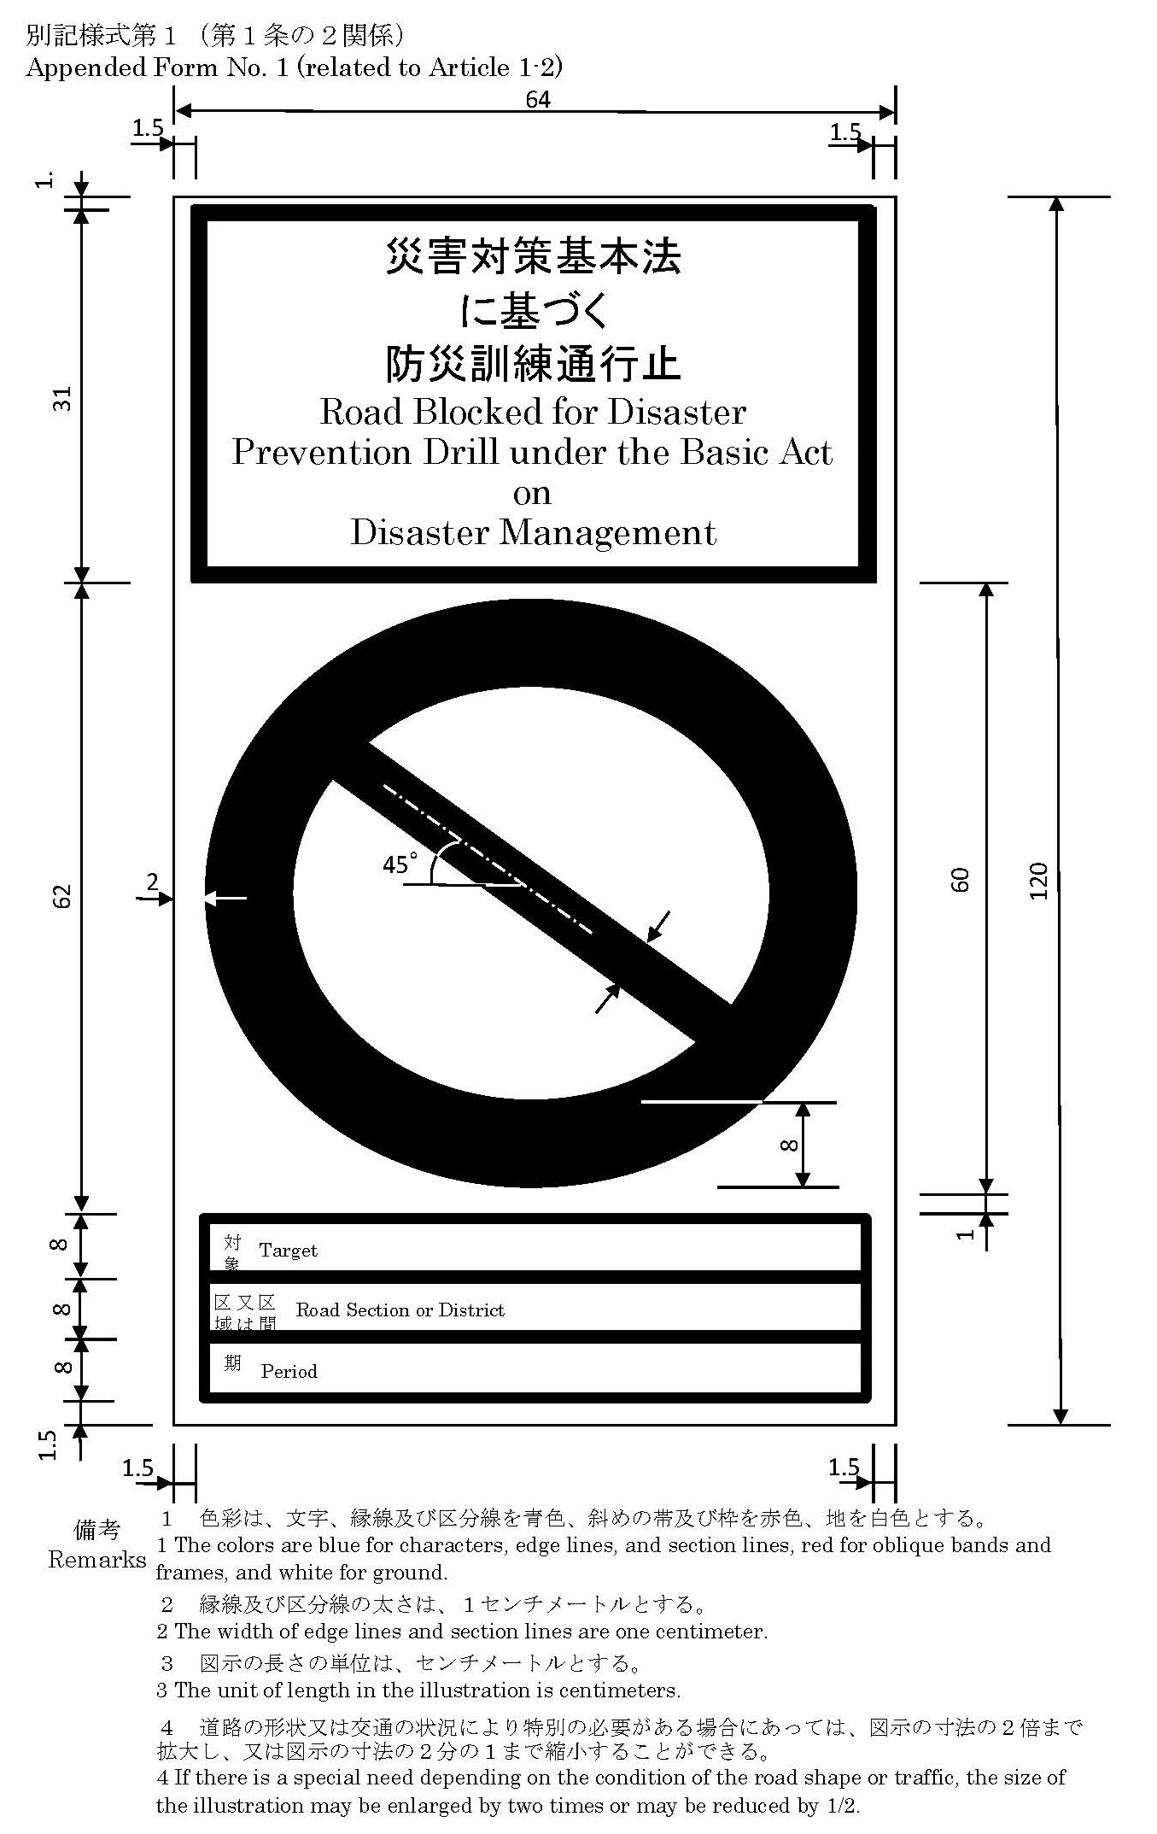
Appended Form No. 2 (related to Article 5)
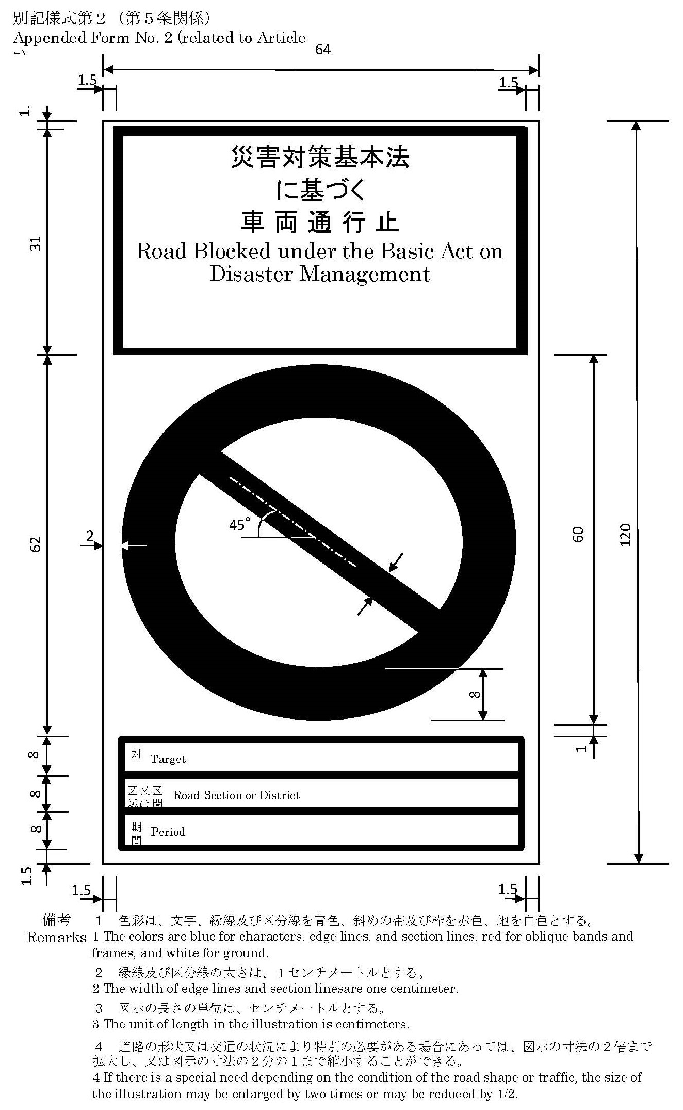
Appended Form No. 3 (related to Article 6)
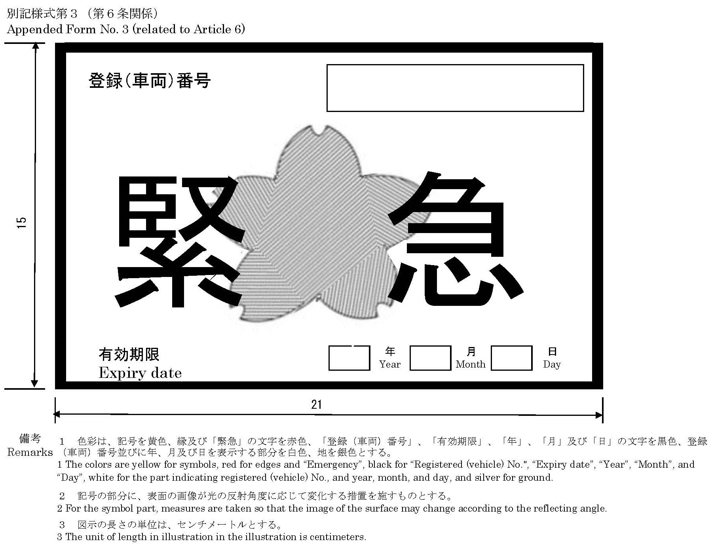
Appended Form No. 4 (related to Article 6)
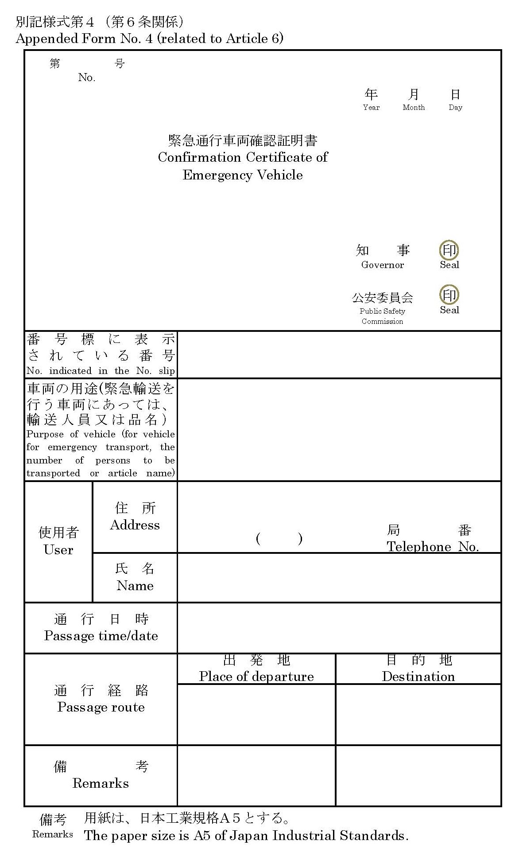
Appended Form No. 5 (related to Article 7)
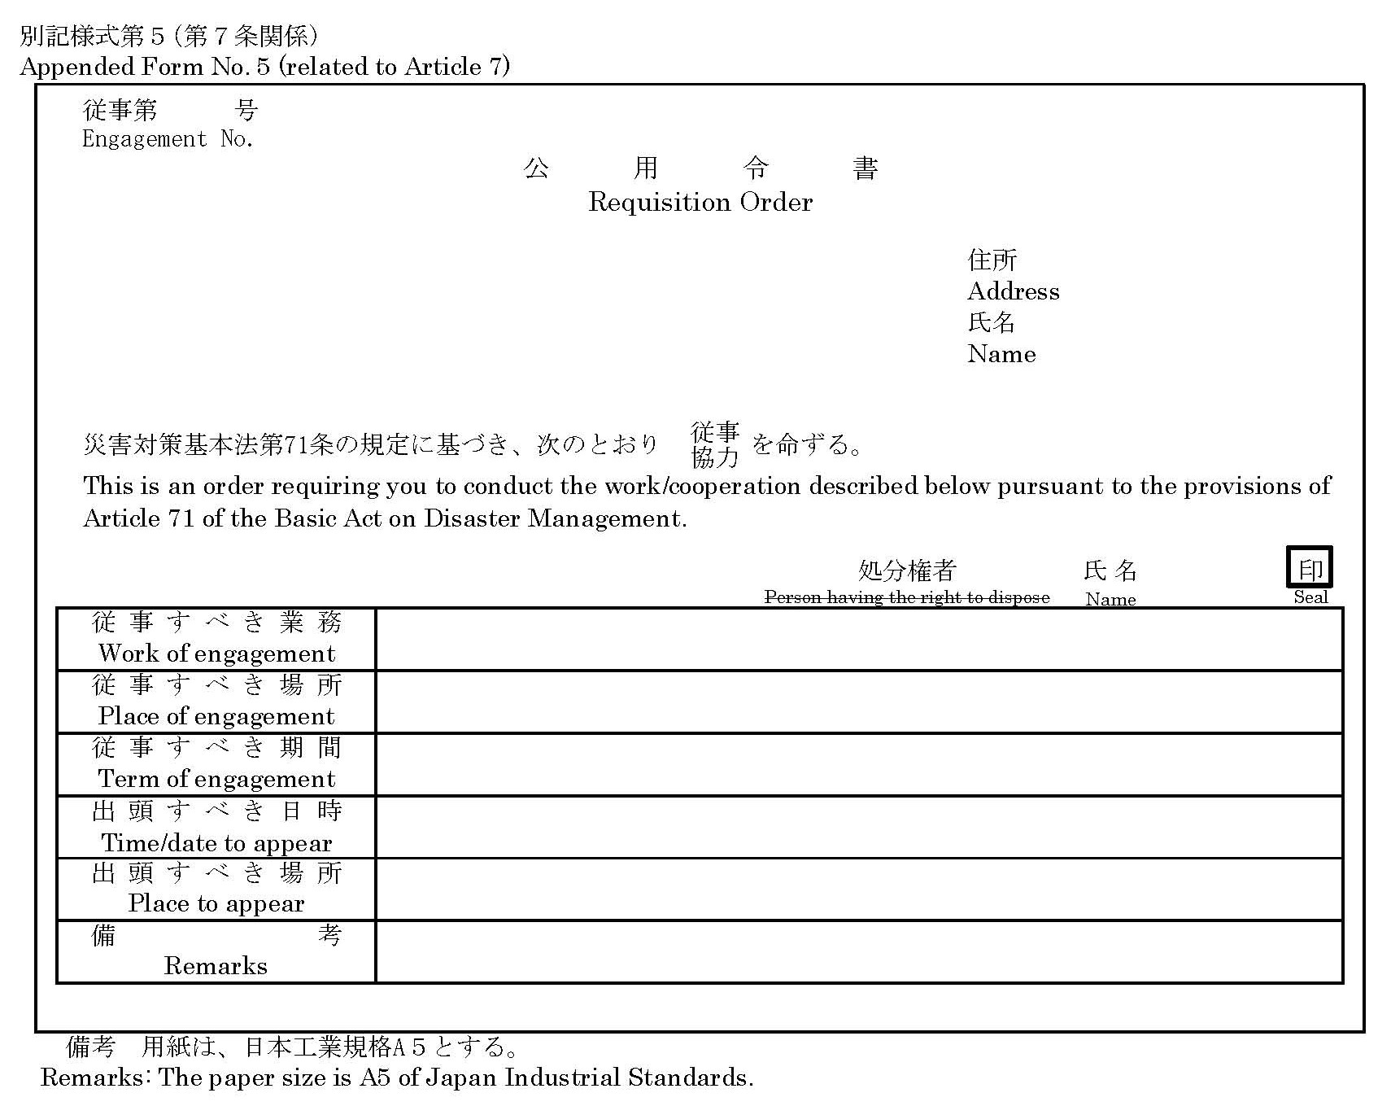
Appended Form No. 6 (related to Article 7)
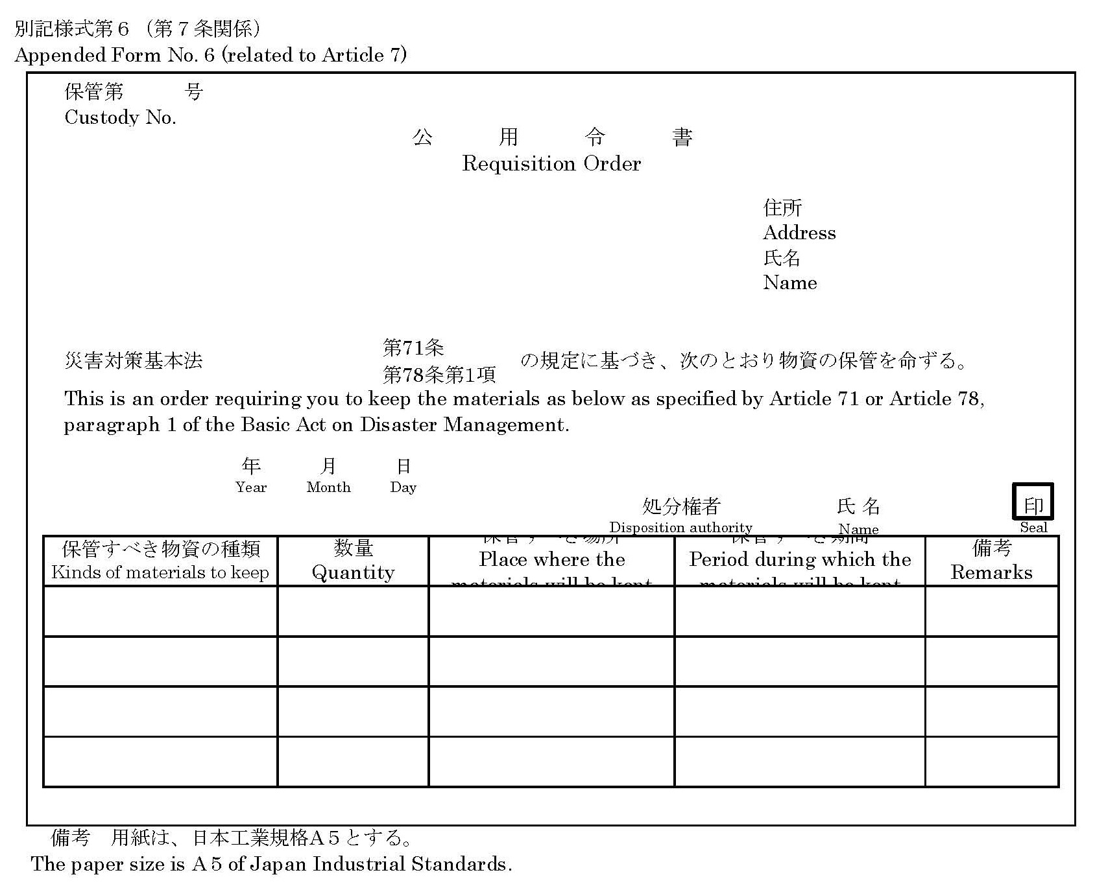
Appended Form No. 7 (related to Article 7)
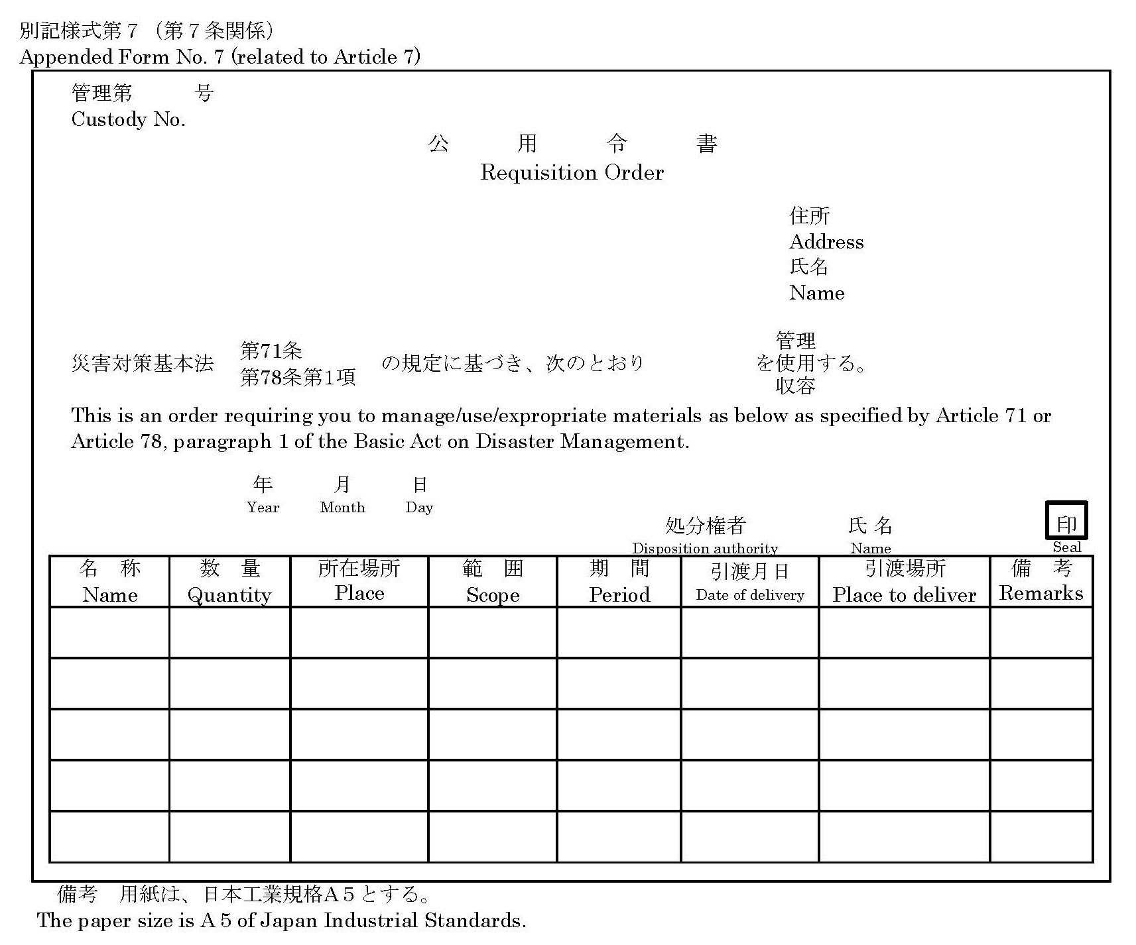
Appended Form No. 8 (related to Article 7)
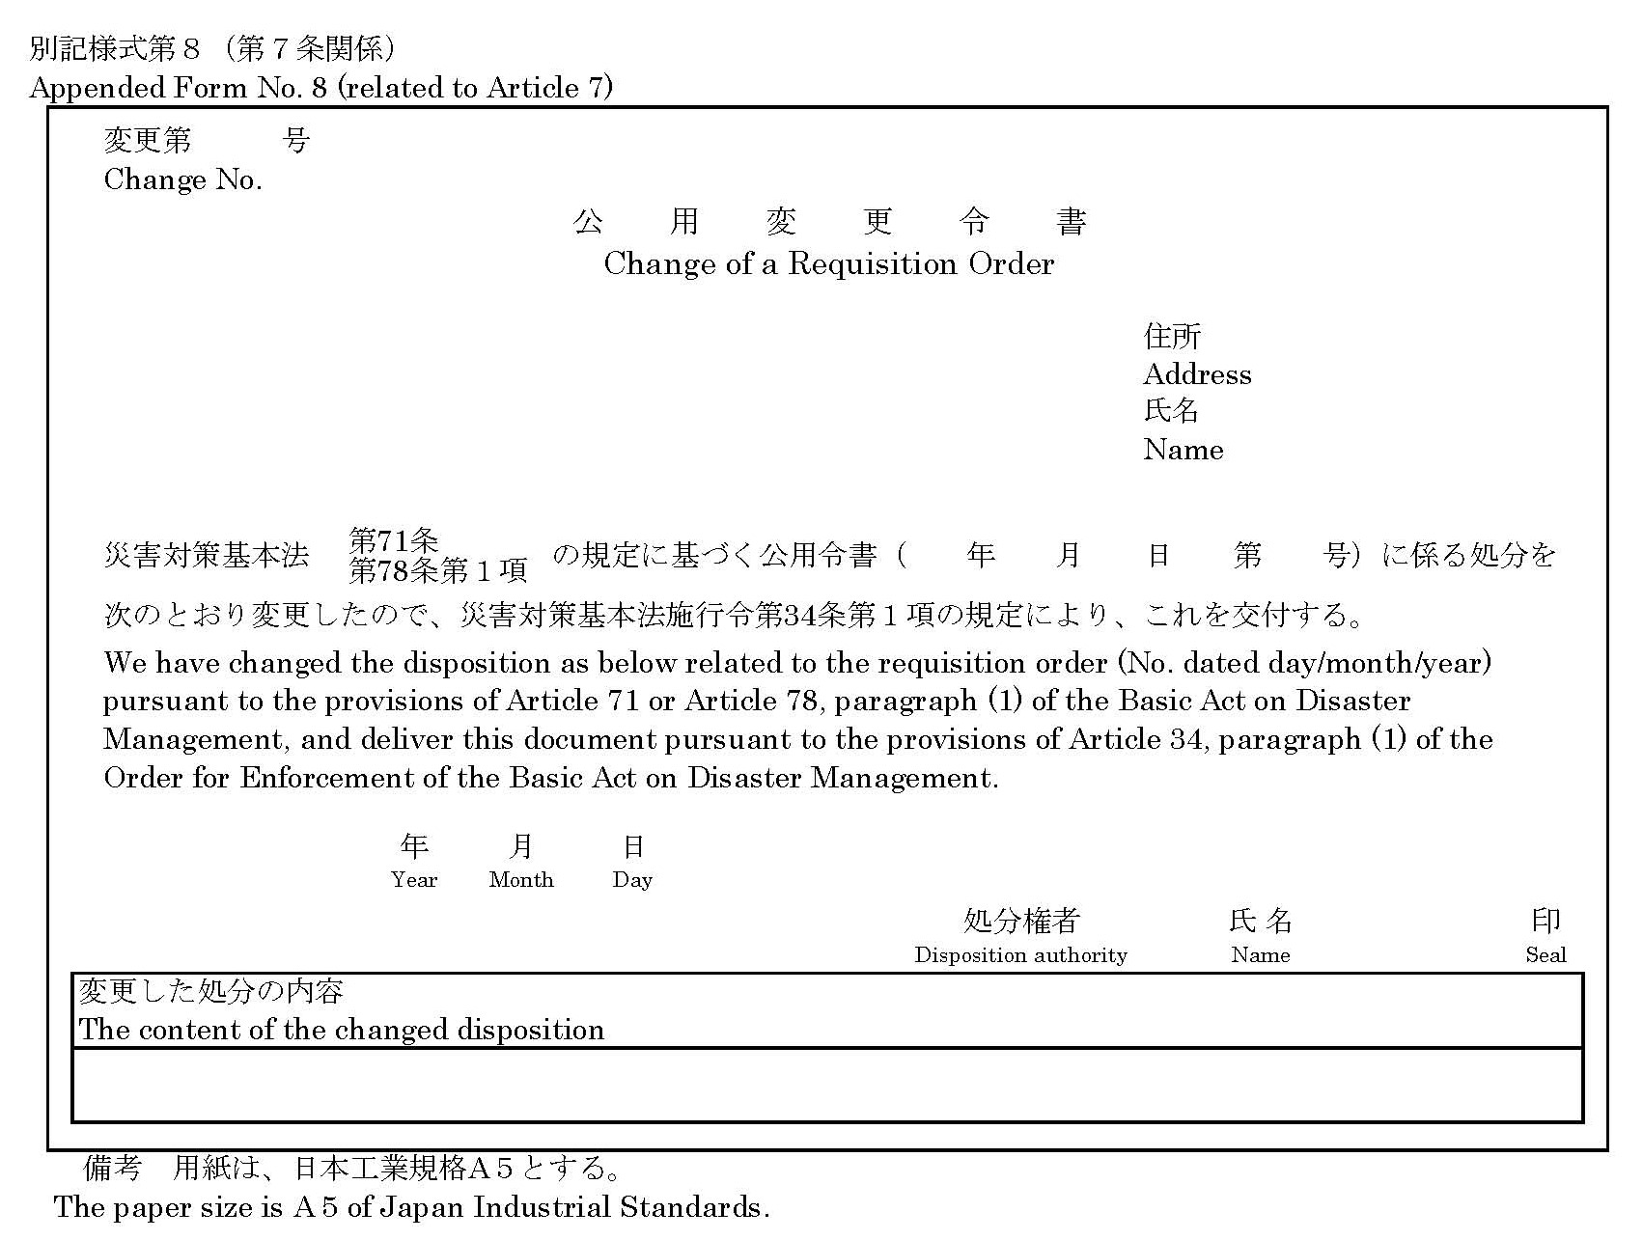
Appended Form No. 9 (related to Article 7)
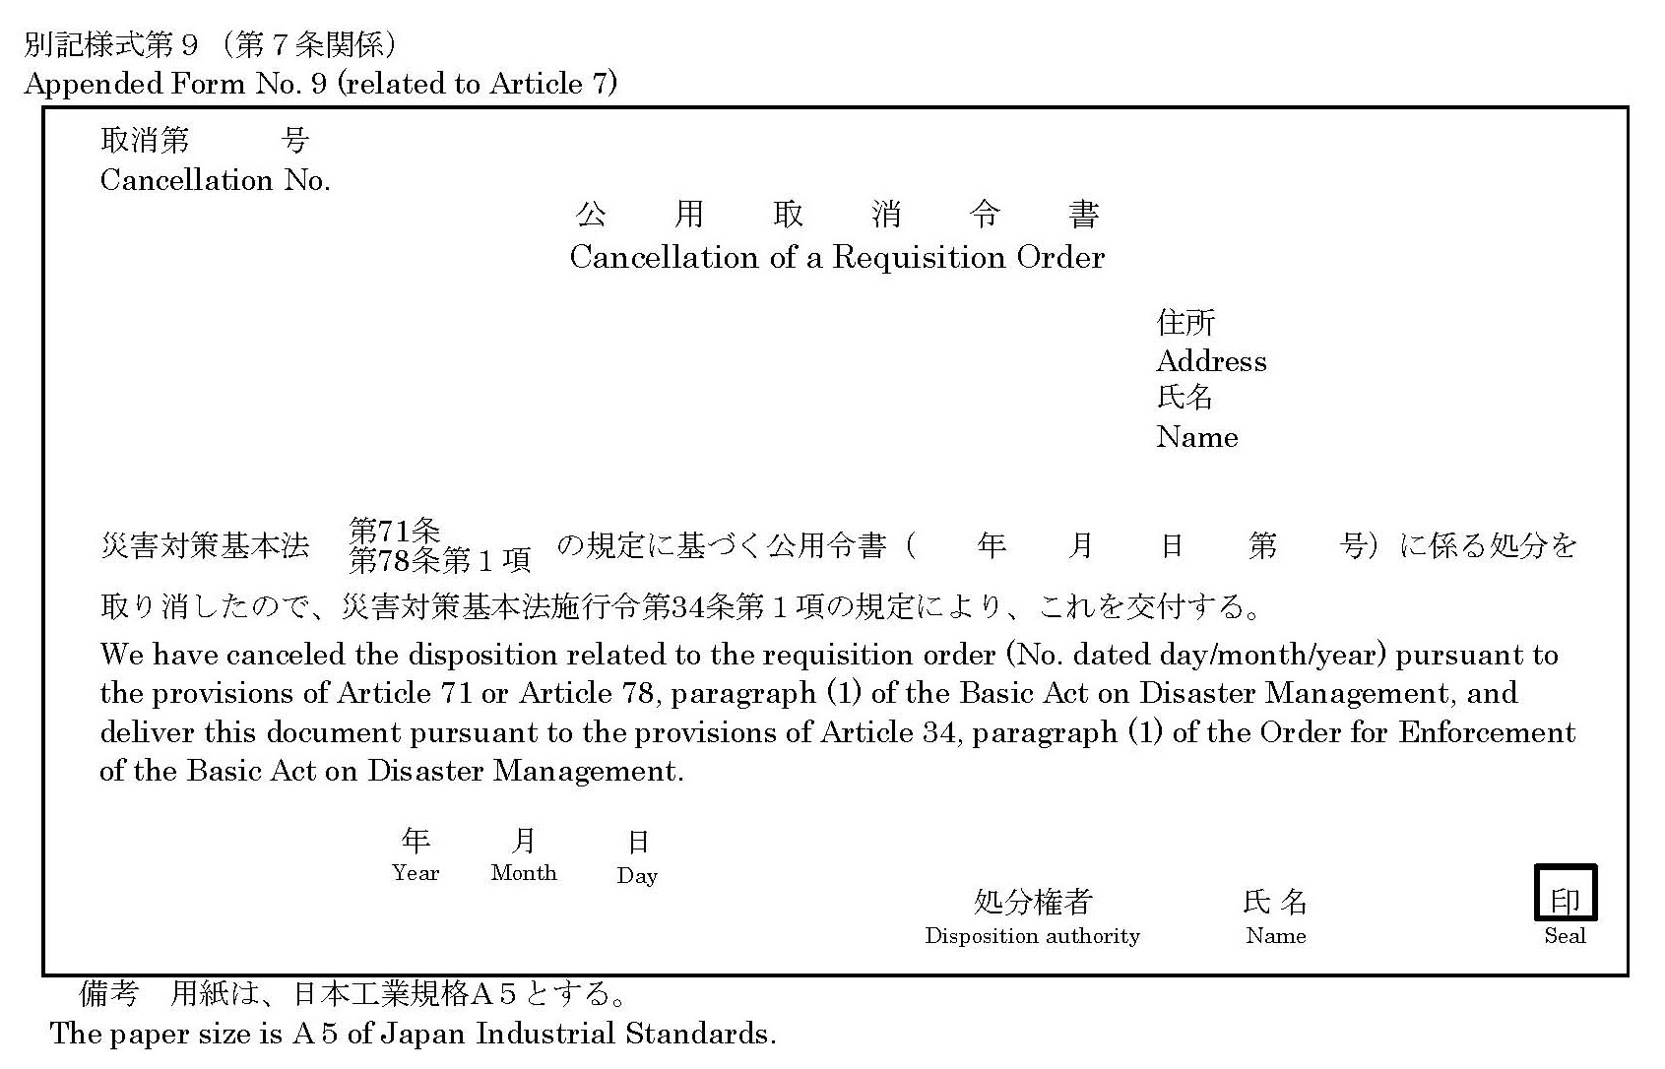
Appended Form No. 10 (related to Article 9)
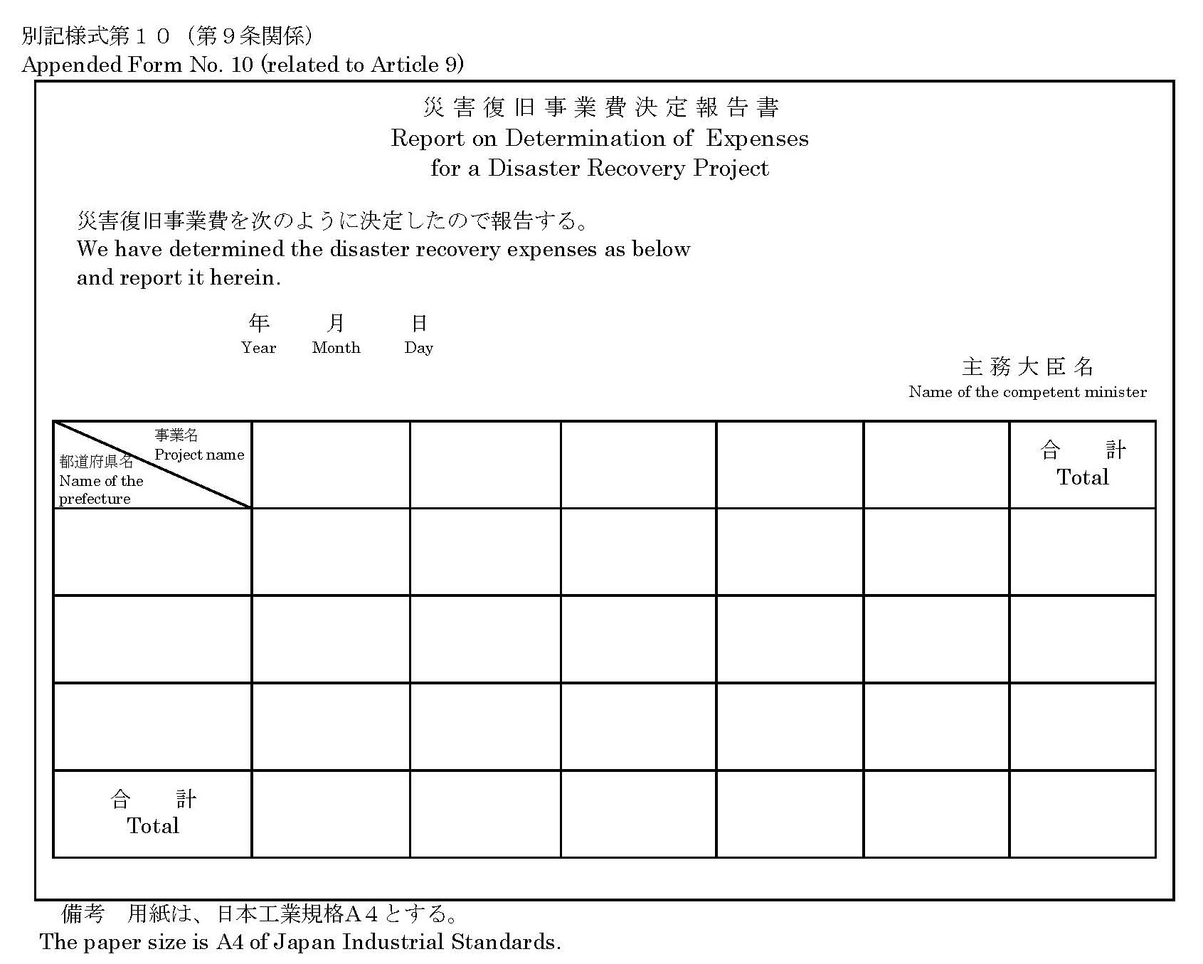
Appended Form No. 11 (related to Article 9)
