災害対策基本法施行規則
Regulation for Enforcement of the Basic Act on Disaster Management

（昭和三十七年九月二十一日総理府令第五十二号）
(Prime Minister's Office Order No. 52 of September 21, 1962)

災害対策基本法を実施するため、並びに災害対策基本法施行令の規定に基づき、災害対策基本法施行規則を次のように定める。
In order to implement the Basic Act on Disaster Management and based on the provisions of the Order for Enforcement of the Basic Act on Disaster Management, the Regulation for Enforcement of the Basic Act on Disaster Management is established as below.

（地区居住者等による提案）
(Proposal by District Residents)
第一条 災害対策基本法（昭和三十六年法律第二百二十三号。以下「法」という。）第四十二条の二第二項の規定により共同して計画提案を行おうとする者は、その全員の氏名及び住所（法人にあつては、その名称及び主たる事務所の所在地）を記載した提案書に次に掲げる図書を添えて、これらを市町村防災会議に提出しなければならない。
Article 1 Persons who intend to jointly make a plan proposal pursuant to the provisions of Article 42-2, paragraph (2) of the Basic Act on Disaster Management (Act No. 223 of 1961; hereinafter referred to as "the Act") must submit to the municipal disaster management council a proposal describing the names and addresses of all its members (in the case of a corporation, the name and location of its main office) together with the following documents:
一 地区防災計画の素案
(i) draft of the district disaster management plan
二 計画提案を行うことができる者であることを証する書類
(ii) document showing that the persons are qualified to make a plan proposal

（防災訓練のための交通の禁止又は制限に係る標示の様式等）
(Form of a Sign concerning Traffic Bans or Restrictions for Disaster Reduction Drill)
第一条の二 災害対策基本法施行令（昭和三十七年政令第二百八十八号。以下「令」という。）第二十条の二第一項の標示の様式は、別記様式第一のとおりとする。
Article 1-2 (1) The form of a sign set forth in Article 20-2, paragraph (1) of the Order for Enforcement of the Basic Act on Disaster Management (Cabinet Order No. 288 of 1962; hereinafter referred to as "the Order") is to be as set forth in the appended form 1.
２ 令第二十条の二第一項の規定により標示を設置する場所は、歩行者又は車両の道路における通行を禁止し、又は制限しようとする区域又は道路の区間の前面及びその区域又は道路の区間内の必要な地点における道路の中央又は左側の路端（歩道と車道の区別のある道路にあつては、歩道の車道側）とする。
(2) The place where a sign is put pursuant to the provisions of Article 20-2, paragraph (1) of the Order is to be in front of the zone or the road section where the road passage of pedestrians or vehicles is going to be banned or restricted and in the center or on the left side of the road (in the case of a road whose sidewalk and roadway are separated, the roadway side of the sidewalk) at necessary points within the zone or the road section.

（令第二十条の三第一号の内閣府令で定める基準）
(Standard as Specified by Cabinet Office Order Set Forth in Article 20-3, Item (i) of the Order)
第一条の三 令第二十条の三第一号の内閣府令で定める基準は、居住者、滞在者その他の者（第一条の八第二号において「居住者等」という。）の受入れの用に供すべき屋上その他の部分（安全区域（令第二十条の三第二号に規定する安全区域をいう。）外にある同号ロに規定する施設である指定緊急避難場所にあつては、当該部分及び当該部分までの避難上有効な階段その他の経路）について、物品の設置又は地震による落下、転倒若しくは移動その他の事由により避難上の支障を生じさせないものであることとする。
Article 1-3 The standard as specified by Cabinet Office Order set forth in Article 20-3, item (i) of the Order is to ensure that no hindrance is caused to evacuation by the placement of an article, or by the article dropping, falling, or moving due to an earthquake, or due to other reasons related to a rooftop or any other part of a facility to be used to receive residents, visitors, and any other persons (referred to as "Residents, etc." in Article 1-8, item (ii)) (in the case of a designated emergency evacuation site which is a facility prescribed in (b) of the same item and located outside (referring to a safety zone prescribed in Article 20-3, item (ii) of the Order), the relevant part and the steps usable in evacuation to the relevant part, and any other route).

（令第二十条の三第二号イの内閣府令で定める技術的基準）
(Technical Standard as Specified by Cabinet Office Order Set Forth in Article 20-3, Item (ii), (a) of the Order)
第一条の四 令第二十条の三第二号イの内閣府令で定める技術的基準は、当該異常な現象により生ずる水圧、波力、振動、衝撃その他の予想される事由により当該施設に作用する力によつて損壊、転倒、滑動又は沈下その他構造耐力上支障のある事態を生じない構造のものであること（当該異常な現象が津波である場合にあつては、次条に規定する技術的基準に適合するものであることを含む。）とする。
Article 1-4 As the technical standard as specified by Cabinet Office Order set forth in Article 20-3, item (ii), (a) of the Order, the structure is to not cause any destruction, falling, sliding, or sinking, or any other situation that is detrimental to structural strength that arises due to a force acting on the facility generated by water pressure, wave pressure, vibration, shock, or other anticipated reasons caused by the relevant extraordinary phenomenon (if the relevant extraordinary phenomenon is a tsunami, conformity to the technical standard prescribed in the following Article is included).

（令第二十条の三第三号イの内閣府令で定める技術的基準）
(Technical Standard as Specified by Cabinet Office Order Set Forth in Article 20-3, item (iii), (a) of the Order)
第一条の五 令第二十条の三第三号イの内閣府令で定める技術的基準は、地震に対する安全性に係る建築基準法（昭和二十五年法律第二百一号）並びにこれに基づく命令及び条例の規定に適合するものであることとする。
Article 1-5 As the technical standard as specified by Cabinet Office Order set forth in Article 20-3, item (iii), (a) of the Order, the structure is to meet the Building Standards Act (Act No. 201 of 1950) concerning safety against earthquakes, as well as Orders and provisions of prefectural or municipal ordinances based on this Act.

（令第二十条の四の内閣府令で定める異常な現象の種類）
(Kinds of Extraordinary Phenomena as Specified by Cabinet Office Order Set Forth in Article 20-4 of the Order)
第一条の六 令第二十条の四の内閣府令で定める異常な現象の種類は、一時的に大量の降雨が生じた場合において下水道その他の排水施設又は河川その他の公共の水域に当該雨水を排水できないことによる浸水及び火砕流、溶岩流、噴石その他噴火に伴い発生する火山現象とする。
Article 1-6 The kinds of extraordinary phenomena as specified by Cabinet Office Order set forth in Article 20-4 of the Order are flooding in cases where there is a sudden heavy rain and the relevant rain water cannot be drained in the sewerage system, any other drainage facilities, rivers, or any other public water areas, and pyroclastic flow, lava flow, cinder, and any other volcanic phenomena caused by volcanic eruption.

（変更の届出）
(Notification of Change)
第一条の七 法第四十九条の五（法第四十九条の七第二項において準用する場合を含む。）の規定による変更の届出は、当該変更の内容を記載した届出書を提出して行うものとする。
Article 1-7 The notification of a change under Article 49-5 of the Act (including as applied mutatis mutandis pursuant to Article 49-7, paragraph (2) of the Act) is to be made by submitting a written notification describing the details of the relevant change.

（指定避難所の公示）
(Public Notice of Designated Shelters)
第一条の七の二 法第四十九条の七第二項の規定により準用する法第四十九条の四第三項の規定により令第二十条の六第一号から第四号までに定める基準に適合する指定避難所（同条第一号から第五号までに定める基準に適合するものを除く。以下この項において「指定一般避難所」という。）を指定したときは、当該指定一般避難所の名称及び所在地その他市町村長が必要と認める事項を公示するものとする。
Article 1-7-2 (1) When designated shelters that meet the standards specified in Article 20-6, items (i) through (iv) of the Order pursuant to the provisions of Article 49-4, paragraph (3) of the Act as applied mutatis mutandis pursuant to Article 49-7, paragraph (2) of the Act (excluding those meeting the standards specified in Article 20-6, items (i) through (v) of the Order; hereinafter referred to as "designated general shelters" in this paragraph) are designated, a public notice is to be made with regard to the names and locations of the designated general shelters and other matters found necessary by the mayor of a municipality.
２ 前項に定めるもののほか、法第四十九条の七第二項の規定により準用する法第四十九条の四第三項の規定により令第二十条の六第一号から第五号までに定める基準に適合する指定避難所（以下この項において「指定福祉避難所」という。）を指定したときは、当該指定福祉避難所の名称、所在地及び当該指定福祉避難所に受け入れる被災者等を特定する場合にはその旨その他市町村長が必要と認める事項を公示するものとする。
(2) Beyond what is provided for in the preceding paragraph, when designated shelters that meet the standards specified in Article 20-6, items (i) through (v) of the Order pursuant to the provisions of Article 49-4, paragraph (3) of the Act as applied mutatis mutandis pursuant to Article 49-7, paragraph (2) of the Act (hereinafter referred to as "designated welfare shelters" in this paragraph) are designated, a public notice is to be made with regard to the names and locations of the designated welfare shelters, the fact that disaster victims, etc. to be accepted at these shelters are designated if such designation is made, and other matters found necessary by the mayor of a municipality.

（災害に関する情報の伝達方法等を居住者等に周知させるための必要な措置）
(Necessary Measures to Fully Inform Residents of the Methods of Transmitting Information on Disaster)
第一条の八 法第四十九条の九の居住者等に周知させるための必要な措置は、次に掲げるものとする。
Article 1-8 Necessary measures to fully inform residents, etc. set forth in Article 49-9 of the Act are to be as set forth below:
一 異常な現象が発生した場合において人の生命又は身体に危険が及ぶおそれがあると認められる土地の区域を表示した図面に法第四十九条の九に規定する事項を記載したもの（電子的方式、磁気的方式その他人の知覚によつては認識することができない方式で作られる記録を含む。）を、印刷物の配布その他の適切な方法により、各世帯に提供すること。
(i) each household will be provided with a plan indicating the area of land which is found likely to risk the lives or bodies of people when an extraordinary phenomenon occurs, and containing descriptions of matters prescribed in Article 49-9 of the Act (including records made by electronic methods, magnetic methods, and any other methods not recognized by the human senses) by distributing printed materials or any other proper method;
二 前号の図面に表示した事項及び記載した事項に掲げる情報、インターネットの利用その他の適切な方法により、居住者等がその提供を受けることができる状態に置くこと。
(ii) residents, etc. will be placed in a situation where they can receive the relevant information through the information set forth in the matters shown and indicated in the plan set forth in the preceding item, by the use of the Internet, or other appropriate methods.

（令第二十条の六の内閣府令で定める基準）
(Standard as Specified by Cabinet Office Order Set Forth in Article 20-6 of the Order)
第一条の九 令第二十条の六の内閣府令で定める基準は、次のとおりとする。
Article 1-9 The standard as specified by Cabinet Office Order set forth in Article 20-6 of the Order is to be as set forth below:
一 高齢者、障害者、乳幼児その他の特に配慮を要する者（以下この条において「要配慮者」という。）の円滑な利用を確保するための措置が講じられていること。
(i) measures are taken to ensure that the elderly, disabled persons, infants, and others requiring special care (hereinafter referred to as "persons requiring special care" in this Article) can use the facilities smoothly;
二 災害が発生した場合において要配慮者が相談し、又は助言その他の支援を受けることができる体制が整備されること。
(ii) systems will be prepared to enable persons requiring special care to engage in consultation or receive advice or any other support when a disaster occurs;
三 災害が発生した場合において主として要配慮者を滞在させるために必要な居室が可能な限り確保されること。
(iii) as much as possible, necessary residential facilities will be secured where mainly persons requiring special care can stay when a disaster occurs.

（被害状況等の報告）
(Report on Conditions of Disaster)
第二条 令第二十一条の規定による災害の状況及びこれに対してとられた措置の概要の報告は、災害の発生及びその経過に応じて逐次行うものとし、当該災害に対する応急措置が完了した後二十日以内に最終の報告を行うものとする。
Article 2 (1) The report on the conditions of a disaster and the outline of the measures taken for the disaster under Article 21 of the Order is to be made based upon the occurrence of the disaster and periodically thereafter, and the final report is to be made within 20 days after the date of completion of emergency measures for the relevant disaster.
２ 令第二十一条第四号に規定する被害の程度に関する報告は、法第五十三条第一項及び第二項の規定により市町村及び都道府県が行うものにあつては別表第一に掲げる事項について、同条第三項の規定により指定公共機関の代表者が行うものにあつては被害の概算額について、同条第四項の規定により指定行政機関の長が行うものにあつては別表第二に掲げる事項のうちその所掌事務に係るものについて行うものとする。
(2) The report on the degree of the damage prescribed in Article 21, item (iv) of the Order is to be made on the matters set forth in appended table 1 in the case of a report to be made by a municipality and prefecture pursuant to the provisions of Article 53, paragraphs (1) and (2) of the Act, on the estimated amount of the damage caused by the disaster in the case of a report to be made by the representative of a designated public corporation pursuant to the provisions of paragraph (3) of the same Article, and on the matters concerning the function under their jurisdiction out of the matters set forth in appended table 2 in the case of a report to be made by the head of a designated administrative organ pursuant to the provisions of paragraph (4) of the same Article.

（令第二十三条の内閣府令で定める管区海上保安本部の事務所）
(Office of Regional Coast Guard Headquarters as Specified by Cabinet Office Order Set Forth in Article 23 of the Order)
第二条の二 令第二十三条の管区海上保安本部の事務所は、海上保安監部、海上保安部、海上保安航空基地及び海上保安署とする。
Article 2-2 The office of regional coast guard headquarters set forth in Article 23 of the Order is to be coast guard offices, air stations, and coast guard stations.

（法第六十一条の四第四項の内閣府令で定める者等）
(Persons Designated by Cabinet Office Order Set Forth in Article 61-4, Paragraph (4) of the Act)
第二条の三 法第六十一条の四第四項の内閣府令で定める者は、同項の要避難者を受け入れるべき避難場所を管理する者並びに関係指定地方行政機関の長、関係指定公共機関及び関係指定地方公共機関、関係公共的団体その他同項の協議先市町村長が必要と認める者とする。
Article 2-3 (1) The persons designated by Cabinet Office Order set forth in Article 61-4, paragraph (4) of the Act are to be the following: the person that manages the evacuation site to accept people in need of evacuation set forth in the same paragraph; the head of a relevant designated local administrative organ; relevant designated public corporations and designated local public corporations; relevant public organizations; and any other persons found necessary by the consulted mayor set forth in the same paragraph.
２ 法第六十一条の四第六項の内閣府令で定める者は、同項の協議元市町村長の統轄する市町村の区域において協議元市町村長が同項の通知を受けた時に現に要避難者を受け入れている避難場所を管理する者並びに関係指定地方行政機関の長、関係指定公共機関及び関係指定地方公共機関、関係公共的団体その他協議元市町村長が必要と認める者とする。
(2) The persons designated by Cabinet Office Order set forth in Article 61-4, paragraph (6) of the Act are to be the following: the person that manages an evacuation site which actually accepted people in need of evacuation in the area of the municipality under the control of the consulting mayor set forth in the same paragraph when the consulting mayor received the notification set forth in the same paragraph; the head of a relevant designated local administrative organ; relevant designated public corporations and relevant designated local public corporations; relevant public organizations; and any other persons found necessary by the consulting mayor.
３ 第一項の規定は、法第六十一条の五第六項及び第六十一条の六第五項の内閣府令で定める者について準用する。この場合において、第一項中「協議先市町村長」とあるのは、「都道府県外協議先市町村長」と読み替えるものとする。
(3) The provisions of paragraph (1) apply mutatis mutandis to the persons designated by Cabinet Office Order set forth in Article 61-5, paragraph (6) and Article 61-6, paragraph (5) of the Act. In this case, the term "consulted mayor" in paragraph (1) is deemed to be replaced with "consulted mayor outside the prefecture."
４ 第二項の規定は、法第六十一条の五第十項及び第六十一条の六第七項の内閣府令で定める者について準用する。
(4) The provisions of paragraph (2) apply mutatis mutandis to the persons designated by Cabinet Office Order set forth in Article 61-5, paragraph (10) and Article 61-6, paragraph (7) of the Act.

（令第二十四条の内閣府令で定める管区海上保安本部の事務所）
(Office of Regional Coast Guard Headquarters as Specified by Cabinet Office Order Set Forth in Article 24 of the Order)
第二条の四 令第二十四条の管区海上保安本部の事務所は、海上保安監部、海上保安部、海上保安航空基地又は海上保安署とする。
Article 2-4 The office of regional coast guard headquarters set forth in Article 24 of the Order is to be coast guard offices, air stations and coast guard stations.

（令第二十四条の内閣府令で定める部隊等の長）
(Commanding Officers of Units as Specified by Cabinet Office Order Set Forth in Article 24 of the Order)
第三条 令第二十四条の自衛隊法（昭和二十九年法律第百六十五号）第八条に規定する部隊等の長は、次に掲げる者とする。
Article 3 The commanding officers of units prescribed in Article 8 of the Self-Defense Forces Act (Act No. 165 of 1954) set forth in Article 24 of the Order are to be as set forth below:
一 方面総監
(i) Commanding General of Army, Ground Self-Defense Force
二 師団長
(ii) Division Commanding General of Army, Ground Self-Defense Force
三 旅団長
(iii) Brigade Commanding General of Army, Ground Self-Defense Force
四 駐屯地司令の職にある自衛隊法第八条に規定する部隊等（第十三号において「部隊等」という。）の長
(iv) commanding officers of units prescribed in Article 8 of the Self-Defense Forces Act in charge of command at a station (referred to as "units, etc." in item (xiii))
五 航空群司令（航空方面隊司令部の所在地に所在する航空群の長を除く。）
(v) Commander, Fleet Air Wing, Maritime Self-Defense Force (excluding the head of the Fleet Air Wing stationed at a seat of a district Air Defense Force headquarters)
六 地方総監
(vi) Commandant, Regional District, Maritime Self-Defense Force
七 基地隊司令
(vii) Commander, Sub Area Activity, Maritime Self-Defense Force
八 航空隊司令（航空群司令部又は地方総監部の所在地に所在する航空隊の長を除く。）
(viii) Commanding Officer, Air Squadron (excluding the head of the air squadron stationed at a seat of a headquarters fleet air wing or a headquarters regional district)
九 教育航空群司令
(ix) Commander, Air Training Group, Maritime Self-Defense Force
十 航空総隊司令官
(x) Commander, Air Defense Command, Air Self-Defense Force
十一 航空方面隊司令官
(xi) Commander, District Air Defense Force, Air Self-Defense Force
十二 基地司令の職にある部隊等の長（駐屯地の所在地に所在する基地又は航空総隊司令部若しくは航空方面隊司令部の所在する基地の基地司令の職にある部隊等の長を除く。）
(xii) commanding officers of units, etc. in charge of command at a base (excluding the head of units, etc. in charge of command at the base located at a station or the base where air defense command headquarters, or district air force headquarters are located)

（法第六十四条第九項の内閣府令で定める部隊等の長）
(Commanding Officers of Units as Specified by Cabinet Office Order Set Forth in Article 64, Paragraph (9) of the Act)
第四条 法第六十四条第九項の自衛隊法第八条に規定する部隊等の長は、前条各号に掲げる者のうち、その勤務官署が法第六十四条第八項において準用する同条第二項前段の規定により除去された同項に規定する工作物等が設置されていた場所の直近にあるものとする。
Article 4 The commanding officers of units, etc. prescribed in Article 8 of the Self-Defense Forces Act set forth in Article 64, paragraph (9) of the Act are to be the persons set forth in each of the items of the preceding Article, whose offices are nearest to the places where structures, etc. prescribed in Article 64, paragraph (2) of the Act, which had been deleted pursuant to the provisions of the first sentence of Article 64, paragraph (2), as applied mutatis mutandis pursuant to Article 64, paragraph (8) of the Act, were established.

（災害時における交通の規制に係る標示の様式等）
(Form of a Sign concerning Traffic Restrictions in Time of Disaster)
第五条 令第三十二条第一項の標示の様式は、別記様式第二のとおりとする。
Article 5 (1) The form of a sign set forth in Article 32, paragraph (1) of the Order is to be as set forth in appended form 2.
２ 令第三十二条第一項の規定により標示を設置する場所は、緊急通行車両以外の車両の道路における通行を禁止し、又は制限しようとする区域又は道路の区間の前面及びその区域又は道路の区間内の必要な地点における道路の中央又は左側の路端（歩道と車道の区別のある道路にあつては、歩道の車道側）とする。
(2) The place where a sign is installed pursuant to the provisions of Article 32, paragraph (1) of the Order is to be in front of the zone or the road section where the road passage of vehicles other than emergency vehicles is going to be banned or restricted and in the center or on the left side of the road (in the case of a road whose sidewalk and roadway are separated, the roadway side of the sidewalk) at necessary points within the zone or the road section.

（緊急通行車両についての確認に係る標章の様式等）
(Form of a Sign concerning Confirmation Pertaining to Emergency Vehicle)
第六条 令第三十三条第二項の標章の様式は、別記様式第三のとおりとする。
Article 6 (1) The form of a sign set forth in Article 33, paragraph (2) of the Order is to be as set forth in appended form 3.
２ 令第三十三条第二項の証明書の様式は、別記様式第四のとおりとする。
(2) The form of a certificate set forth in Article 33, paragraph (2) of the Order is to be as set forth in appended form 4.

（公用令書等の様式）
(Form of Requisition Order)
第七条 令第三十四条第二項の公用令書、公用変更令書及び公用取消令書の様式は、それぞれ別記様式第五から別記様式第七まで、別記様式第八及び別記様式第九のとおりとする。
Article 7 The form of a requisition order, requisition change order, and requisition cancellation order set forth in Article 34, paragraph (2) of the Order is to be as set forth in appended forms 5 through 7, and appended forms 8 and 9, respectively.

（身分を示す証票）
(Identification)
第八条 法第八十三条第二項に規定する身分を示す証票は、その職員の所属する都道府県若しくは市町村又は指定行政機関若しくは指定地方行政機関において発行する身分証明書とする。
Article 8 The proof of identification prescribed in Article 83, paragraph (2) of the Act is to be the identification card issued by the prefecture or municipality, or the designated administrative organ or designated local administrative organ to which the officials belong.

（法第八十六条の八第四項の内閣府令で定める者等）
(Persons as Designated by Cabinet Office Order Set Forth in Article 86-8, Paragraph (4) of the Act)
第八条の二 法第八十六条の八第四項の内閣府令で定める者は、同項の被災住民を受け入れるべき避難所を管理する者並びに関係指定地方行政機関の長、関係指定公共機関及び関係指定地方公共機関、関係公共的団体その他同項の協議先市町村長が必要と認める者とする。
Article 8-2 (1) The persons as designated by Cabinet Office Order set forth in Article 86-8, paragraph (4) of the Act are to be the following: the person that manages the shelter to accept affected residents set forth in the same paragraph; the head of a relevant designated local administrative organ; relevant designated public corporations and designated local public corporations; relevant public organizations;, and any other persons found necessary by the consulted mayor set forth in the same paragraph.
２ 法第八十六条の八第六項の内閣府令で定める者は、同項の協議元市町村長の統轄する市町村の区域において協議元市町村長が同項の通知を受けた時に現に被災住民を受け入れている避難所を管理する者並びに関係指定地方行政機関の長、関係指定公共機関及び関係指定地方公共機関、関係公共的団体その他協議元市町村長が必要と認める者とする。
(2) The persons designated by Cabinet Office Order set forth in Article 86-8, paragraph (6) of the Act are to be the following: the person that manages a shelter which actually accepted affected residents at the area of the municipality under the control of the consulting mayor set forth in the same paragraph when the consulting mayor received the notification set forth in the same paragraph; the head of a relevant designated local administrative organ; relevant designated public corporations and relevant designated local public corporations; relevant public organizations; and any other persons found necessary by the consulting mayor.
３ 第一項の規定は、法第八十六条の九第六項の内閣府令で定める者について準用する。この場合において、第一項中「協議先市町村長」とあるのは、「都道府県外協議先市町村長」と読み替えるものとする。
(3) The provisions of paragraph (1) apply mutatis mutandis to the persons designated by Cabinet Office Order set forth in Article 86-9, paragraph (6) of the Act. In this case, the term "consulted mayor" in paragraph (1) is deemed to be replaced with "consulted mayor outside the prefecture".
４ 第二項の規定は、法第八十六条の九第十項の内閣府令で定める者について準用する。この場合において、第二項中「協議元市町村長」とあるのは、「都道府県外協議元市町村長」と読み替えるものとする。
(4) The provisions of paragraph (2) apply mutatis mutandis to the persons designated by Cabinet Office Order set forth in Article 86-9, paragraph (10) of the Act. In this case, the term "consulting mayor" in paragraph (2) is deemed to be replaced with "consulting mayor outside the prefecture".
５ 法第八十六条の十一後段の規定により読み替えて適用する法第八十六条の九第九項の内閣府令で定める者は、法第八十六条の十一前段の災害の発生によりその全部又は大部分の事務を行うことができなくなつた市町村の市町村長及び当該市町村の区域において同条後段の規定により読み替えて適用する法第八十六条の九第九項の協議元都道府県知事が同項の通知を受けた時に現に被災住民を受け入れている避難所を管理する者並びに関係指定地方行政機関の長、関係指定公共機関及び関係指定地方公共機関、関係公共的団体その他協議元都道府県知事が必要と認める者とする。
(5) The persons designated by Cabinet Office Order set forth in Article 86-9, paragraph (9) of the Act, to be applied by replacing the terms pursuant to the provisions of the second sentence of Article 86-11 of the Act, are to be the mayor of a municipality who has become unable to conduct all or the majority of the affairs due to occurrence of a disaster set forth in the first sentence of Article 86-11 of the Act; the administrator of the shelter which had actually accepted affected residents in the area of the municipality when the consulting prefectural governor set forth in Article 86-9, paragraph (9) of the Act, to be applied by replacing the terms pursuant to the provisions of the second sentence of the same Article, has received notification set forth in the same paragraph; the head of relevant designated local administrative organs; relevant designated public corporations and designated local public corporations; relevant public organizations; and any other persons found necessary by the consulting prefectural governor.

（安否情報の提供等）
(Provision of Safety Information)
第八条の三 法第八十六条の十五第一項の規定により安否情報について照会をしようとする者（以下この条において「照会者」という。）は、都道府県知事又は市町村長に対し、次の各号に掲げる事項を明らかにして行わなければならない。
Article 8-3 (1) The person who intends to inquire about Safety Information pursuant to the provisions of Article 86-15, paragraph (1) of the Act (hereinafter referred to as "inquirer" in this Article) must clarify the matters set forth in each of the following items to the prefectural governor or the mayor of a municipality:
一 照会者の氏名、住所（法人その他の団体にあつてはその名称、代表者の氏名及び主たる事務所の所在地）その他の照会者を特定するために必要な事項
(i) name and address of Inquirer (in the case of a corporation or any other group, its name, the name of the representative and address of its main office), and other necessary matters to identify the Inquirer
二 照会に係る被災者の氏名、住所又は居所、生年月日及び性別
(ii) name, domicile or residence, date of birth, and sex of disaster victim related to the inquiry
三 照会をする理由
(iii) reasons for inquiry
２ 照会者は、前項の規定により明らかにした同項第一号に掲げる事項が記載されている運転免許証、健康保険の被保険者証、行政手続における特定の個人を識別するための番号の利用等に関する法律（平成二十五年法律第二十七号）第二条第七項に規定する個人番号カード、出入国管理及び難民認定法（昭和二十六年政令第三百十九号）第十九条の三に規定する在留カード、日本国との平和条約に基づき日本の国籍を離脱した者等の出入国管理に関する特例法（平成三年法律第七十一号）第七条第一項に規定する特別永住者証明書その他法律又はこれに基づく命令の規定により交付された書類であつて当該照会者が本人であることを確認するに足りるものを提示し、又は提出しなければならない。ただし、照会者が遠隔の地に居住している場合その他この方法によることができない場合においては、都道府県知事又は市町村長が適当と認める方法によることができる。
(2) The Inquirer must show or submit their driver's license, health insurance card, Individual Number Card prescribed in Article 2, paragraph (7) of the Act on the Use of Numbers to Identify a Particular Individual in Administrative Procedures (Act No. 27 of 2013), residence card prescribed in Article 19-3 of the Immigration Control and Refugee Recognition Act (Cabinet Order No. 319 of 1951), special permanent resident certificate prescribed in Article 7, paragraph (1) of the Special Act on the Immigration Control of, Inter Alia, Those Who Have Lost Japanese Nationality Pursuant to the Treaty of Peace with Japan (Act No. 71 of 1991) describing the matters set forth in item (i) of the preceding paragraph as identified by the provisions of the same paragraph or a document delivered pursuant to the provisions of laws or an order based on the laws sufficiently verifying the identity of the inquirer; provided, however, that if the inquirer lives in a remote place or otherwise cannot do so by this method, the method may be the one which the prefectural governor or the mayor of a municipality deems to be suitable.
３ 第一項の照会を受けた都道府県知事又は市町村長は、次の各号に掲げる場合の区分に応じて、当該各号に定める情報を提供することができる。ただし、当該照会が不当な目的によるものと認めるとき又は照会に対する回答により知り得た事項が不当な目的に使用されるおそれがあると認めるときは、この限りでない。
(3) The prefectural governor or the mayor of a municipality who received the inquiry as specified by paragraph (1) may provide the information specified by each of these items according to the classification of the case set forth in each of the following items; provided, however, that this does not apply if the prefectural governor or mayor of a municipality finds that the inquiry has an unjust purpose or if the matters which the inquirer has come to know from the reply are likely to be used for an unjust purpose:
一 照会者が当該照会に係る被災者の同居の親族（婚姻の届出をしないが事実上婚姻関係と同様の事情にある者その他婚姻の予約者を含む。）である場合 照会に係る被災者の居所、負傷若しくは疾病の状況又は連絡先その他安否の確認に必要と認められる情報
(i) if the inquirer is a relative living together with the disaster victim related to the inquiry (including the case where notification of marriage is not yet submitted but the person is actually in a marital relationship or is engaged), the information on residence, the condition of injury or illness, or the contact and any other information which is found necessary to ascertain safety pertaining to the disaster victim related to the inquiry;
二 照会者が当該照会に係る被災者の親族（前号に掲げる者を除く。）又は職場の関係者その他の関係者である場合 照会に係る被災者の負傷又は疾病の状況
(ii) if the inquirer is a relative of the disaster victim related to the inquiry (excluding those set forth in the preceding item), a company co-worker, or any other relevant person, the condition on injury or illness of the disaster victim related to the inquiry;
三 照会者が当該照会に係る被災者の知人その他の当該被災者の安否情報を必要とすることが相当であると認められる者である場合 照会に係る被災者について保有している安否情報の有無
(iii) if the Inquirer is an acquaintance of the disaster victim related to the inquiry or any other person who is found to have a reasonable need to know the safety information of the disaster victim, whether they have the Safety Information of the disaster victim related to the inquiry or not.
４ 前項の規定にかかわらず、第一項の照会を受けた都道府県知事又は市町村長は、当該照会に係る被災者が照会に際しその提供について同意をしている安否情報については、その同意の範囲内で、又は公益上特に必要があると認めるときは、必要と認める限度において、当該被災者に係る安否情報を提供することができる。
(4) Notwithstanding the provisions of the preceding paragraph, the prefectural governor or the mayor of a municipality who received the inquiry set forth in paragraph (1) may provide the safety information of the disaster victim within the scope of their consent on the safety information which the disaster victim related to the inquiry has agreed to provide on an inquiry, or to the extent found necessary, if found particularly necessary for public interest.

（被災者台帳の作成）
(Preparation of Disaster Victim Registers)
第八条の四 法第九十条の三第一項の規定による被災者台帳の作成は、被災者生活再建支援法（平成十年法律第六十六号）第四条第二項の規定により市町村長が行うこととされた同法第三条第一項の被災者生活再建支援金の支給に係る被災世帯主からの申請その他の市町村長に対して行われる手続により得た情報その他の情報に基づき行うことができる。
Article 8-4 The preparation of disaster victim registers under Article 90-3, paragraph (1) of the Act may be conducted on the basis of information obtained from applications by disaster victim householders concerning the payment of support for reconstructing the livelihood of disaster victims set forth in Article 3, paragraph (1) of the Act on Support for Reconstructing Livelihoods of Disaster Victims (Act No.66 of 1998) that is to be conducted by the mayor of a municipality pursuant to the provisions of Article 4, paragraph (2) of the same Act, or other procedures performed for the mayor of a municipality, or any other information.

（被災者台帳に記載又は記録する事項）
(Matters to be Described or Recorded in Disaster Victim Registers)
第八条の五 法第九十条の三第二項第八号の内閣府令で定める事項は、次に掲げる事項とする。
Article 8-5 The matters as specified by Cabinet Office Order set forth in Article 90-3, paragraph (2), item (viii) of the Act are to be the matters set forth below:
一 電話番号その他の連絡先
(i) telephone number or other contact address
二 世帯の構成
(ii) structure of the household
三 罹災証明書の交付の状況
(iii) status of issuance of a disaster victim certificate
四 市町村長が台帳情報を当該市町村以外の者に提供することに被災者本人が同意している場合には、その提供先
(iv) if the disaster victim has agreed to the mayor of a municipality providing parties other than the relevant municipality with register information, the parties that receive them
五 前号に定める提供先に台帳情報を提供した場合には、その旨及びその日時
(v) if register information has been provided to the persons specified by the preceding item, to that effect and the date and time
六 被災者台帳の作成に当たつて行政手続における特定の個人を識別するための番号の利用等に関する法律（平成二十五年法律第二十七号）第二条第五項に規定する個人番号を利用する場合には、当該被災者に係る個人番号
(vi) if individual numbers prescribed in Article 2, paragraph (5) of the Act on the Use of Numbers to Identify a Particular Individual in Administrative Procedures (Act No. 27 of 2013) are used in preparing disaster victim registers, the individual number related to the relevant disaster victim
七 前各号に掲げるもののほか、被災者の援護の実施に関し市町村長が必要と認める事項
(vii) beyond what is provided for in each of the preceding items, other matters which the mayor of a municipality finds necessary for the implementation of aid for the disaster victim

（台帳情報の提供に関し必要な事項）
(Necessary Matters related to Provision of Register Information)
第八条の六 法第九十条の四第一項第一号又は第三号の規定により台帳情報の提供を受けようとする者（以下この条において「申請者」という。）は、次の各号に掲げる事項を記載した申請書を当該台帳情報を保有する市町村長に提出しなければならない。
Article 8-6 (1) Those who wish to receive register information pursuant to the provisions of Article 90-4, paragraph (1), item (i) or (iii) of the Act (hereinafter referred to as "applicants" in this Article) must submit an application describing the matters set forth in each of the following items to the mayor of a municipality holding the register information:
一 申請者の氏名及び住所又は居所（法人その他の団体にあつてはその名称、代表者の氏名及び主たる事務所の所在地）
(i) name and domicile or residence of the applicants (in the case of a corporation or any other group, its name, the name of the representative, and address of its main office)
二 申請に係る被災者を特定するために必要な情報
(ii) necessary information to identify a disaster victim related to the application
三 提供を受けようとする台帳情報の範囲
(iii) scope of register information to be received
四 提供を受けようとする台帳情報に申請者以外の者に係るものが含まれる場合には、その使用目的
(iv) if information concerning persons other than the applicants are included in the register information to be provided, the purpose of its use
五 前各号に掲げるもののほか、台帳情報の提供に関し市町村長が必要と認める事項
(v) beyond what is provided for in each of the preceding items, other matters which the mayor of a municipality finds necessary in providing register information
２ 市町村長は、前項の申請があつた場合において、当該申請が不当な目的によるものと認めるとき又は申請者が台帳情報の提供を受けることにより知り得た情報が不当な目的に使用されるおそれがあると認めるときを除き、申請者に対し、当該申請に係る台帳情報（ただし、前条第六号に掲げる事項を除く。）を提供することができる。
(2) When application set forth in the preceding paragraph is made, unless the mayor of a municipality finds that the application has an unjust purpose or that the information which the applicants have come to know by receiving register information is likely to be used for an unjust purpose, the mayor may provide the applicants with register information concerning the application (provided, however, that the matters set forth in item (vi) of the preceding Article are excluded).
３ 法第九十条の四第一項（第一号又は第三号に係る部分に限る。）の規定により市町村長が提供する台帳情報には、前条第六号に掲げる事項を含まないものとする。
(3) The register information which the mayor of a municipality provides pursuant to the provisions of Article 90-4, paragraph (1) of the Act (limited to the part concerning item (i) or (iii)) is to not include the matters set forth in item (vi) of the preceding Article.

（防災会議への報告の様式）
(Form of Report to the Disaster Management Council)
第九条 令第三十七条に規定する災害復旧事業費の概要及び災害復旧事業の実施に関する基準の概要の報告の様式は、別記様式第十及び別記様式第十一のとおりとする。
Article 9 The form of report on the outline of the amount of expenses for a disaster recovery project and the outline of the standard for implementation of a disaster recovery project prescribed in Article 37 of the Order is to be as set forth in appended forms 10 and 11.

附 則
Supplementary Provisions

この府令は、公布の日から施行する。
This Cabinet Office Order comes into effect on the date of proclamation.

附 則 〔平成二十七年十一月三十日内閣府令第六十九号〕
Supplementary Provisions [Cabinet Office Order No. 69 of November 30, 2015]

（経過措置）
(Transitional Measures)
２ 行政手続における特定の個人を識別するための番号の利用等に関する法律の施行に伴う関係法律の整備等に関する法律（以下この項において「番号利用法整備法」という。）第十九条の規定による改正前の住民基本台帳法（昭和四十二年法律第八十一号。以下この項において「旧住民基本台帳法」という。）第三十条の四十四第三項の規定により交付された同条第一項に規定する住民基本台帳カードは、番号利用法整備法第二十条第一項の規定によりなお従前の例によることとされた旧住民基本台帳法第三十条の四十四第九項の規定によりその効力を失う時までの間は、番号利用法第二条第七項に規定する個人番号カードとみなして、この府令による改正後の災害対策基本法施行規則の規定を適用する。
(2) During the period until the register ceases to be effective by the provisions of Article 30-44, paragraph (9) of the Former Residential Basic Register Act where prior laws continue to govern pursuant to the provisions of Article 20, paragraph (1) of the Act on Improvement in Method of Number Use, the residential basic register card delivered pursuant to the provisions of Article 30-44, paragraph (3) of the Residential Basic Register Act (Act No. 81 of 1967; hereinafter referred to as "Former Residential Basic Register Act" in this paragraph) before revision under Article 19 of the Act on Improvement of the Related Acts concerning Enforcement of the Act on the Use of Numbers to Identify a Particular Individual in Administrative Procedures (hereinafter referred to as "Act on Improvement in Method of Number Use" in this paragraph) and prescribed in paragraph (1) of the same Article is deemed as an individual number card prescribed in Article 2, paragraph (7) of the Act on Improvement in Method of Number Use, and the provisions of the Regulation for Enforcement of the Basic Act on Disaster Management after revision by this Cabinet Office Order apply.

別表第一
Appended table 1
一 人的被害に関する事項
(i) Matters on human damage
イ 死者の数
(a) Number of deaths
ロ 行方不明者の数
(b) Number of missing persons
ハ 重傷者の数
(c) Number of severely injured persons
ニ 軽傷者の数
(d) Number of slightly injured persons
二 住家の被害に関する事項
(ii) Matters on residence damage
イ 全壊（全流失・全埋没・全焼失を含む。）棟数並びにこれに居住していた者の人員及び世帯数
(a) Number of completely destroyed houses (including completely washed-away houses, completely buried houses, or completely burned-out houses), and number of people and households who lived there
ロ 半壊（半流失・半埋没・半焼失を含む。）棟数並びにこれに居住していた者の人員及び世帯数
(b) Number of partially destroyed houses (including partially washed-away houses, partially buried houses, and partially burned-out houses), and number of people and households who lived there
ハ 一部破損棟数並びにこれに居住している者の人員及び世帯数
(c) Number of partially damaged houses, and number of people and households who live there
ニ 床上浸水棟数並びにこれに居住している者の人員及び世帯数
(d) Number of houses flooded above the floor level, and number of people and households who live there
ホ 床下浸水棟数並びにこれに居住している者の人員及び世帯数
(e) The number of houses flooded below the floor level, and the number of people and households who live there
三 非住家の被害に関する事項
(iii) Matters on non-residence damage
全壊又は半壊（流失・埋没・焼失を含む。）棟数
Number of completely or partially destroyed houses (including washed-away houses, buried houses, and burned-out houses)
四 田畑の被害に関する事項
(iv) Matters on rice field or farmland damage
イ 田の流失又は埋没面積並びに冠水面積
(a) Area of washed-away or buried rice fields, and flooded area
ロ 畑の流失又は埋没面積並びに冠水面積
(b) Area of washed-away or buried farmland, and flooded area
五 その他の被害に関する事項
(v) Matters on other damage
イ 道路決壊箇所数
(a) Number of destroyed sections of roads
ロ 橋梁流失箇所数
(b) Number of washed-away sections of bridges
ハ 堤防決壊箇所数
(c) Number of destroyed sections of banks
ニ 鉄道不通箇所数
(d) Number of blocked sections of railways
ホ 被害船舶数
(e) Number of damaged vessels
ヘ その他の被害
(f) Matters on other damage
六 り災者に関する事項
(vi) Matters on disaster victims
り災世帯数及び人員
Number of disaster victims and households
七 被害額に関する事項
(vii) Matters on damage amount
指定公共機関の代表者及び指定行政機関の長が報告すべき被害以外の物的被害の概算額
Estimated amount of property damage other than damage which the representatives of designated public corporations or heads of designated administrative organs must report.

別表第二
Appended table 2
一 激甚災害に対処するための特別の財政援助等に関する法律（昭和三十七年法律第百五十号）第三条第一項第一号及び第三号から第十号までの各号中に規定する施設、第七条各号に掲げる施設並びに第十四条、第十六条第一項及び第十七条第一項中に規定する施設にかかる被害の概算額
(i) The estimated amount of damage pertaining to facilities prescribed in Article 3, paragraph (1), items (i) and (iii) through (x) of the Act on Special Financial Support to Deal with the Disaster of Extreme Severity (Act No. 150 of 1962), facilities set forth in each item of Article 7, and facilities prescribed in Article 14, Article 16, paragraph (1), and Article 17, paragraph (1)
二 農林水産業施設災害復旧事業費国庫補助の暫定措置に関する法律（昭和二十五年法律第百六十九号）の規定の適用を受ける施設にかかる被害の概算額
(ii) The estimated amount of damage pertaining to facilities under application of the provisions of the Act on Temporary Measures for Subsidies from National Treasury for Expenses for Project to Recover Facilities for Agriculture, Forestry and Fisheries Damaged by Disaster (Act No. 169 of 1950)
三 前二号に掲げるものを除くほか、法令又は予算により、その災害復旧事業費につき国が負担し、若しくは補助する施設（国有財産法（昭和二十三年法律第七十三号）第三条第二項に規定する公用財産、皇室用財産及び森林経営用財産であるものを除く。）に係る被害の概算額
(iii) Beyond what is provided for in the preceding two items, the estimated amount of damage related to facilities which the State bears or subsidizes concerning their disaster recovery project expenses under laws and regulations or the budget (excluding government properties, imperial properties, and forest management properties prescribed in Article 3, paragraph (2) of the National Property Act (Act No. 73 of 1948))
四 農作物、林産物、畜産物（家畜・家きんを含む。）、蚕繭及び水産物の被害の概算額
(iv) The estimated amount of damage pertaining to agriculture products, forest products, animal products (including domestic animal and poultry), silk culture and marine products

別記様式第１（第１条の２関係）
Appended Form No. 1 (related to Article 1-2)
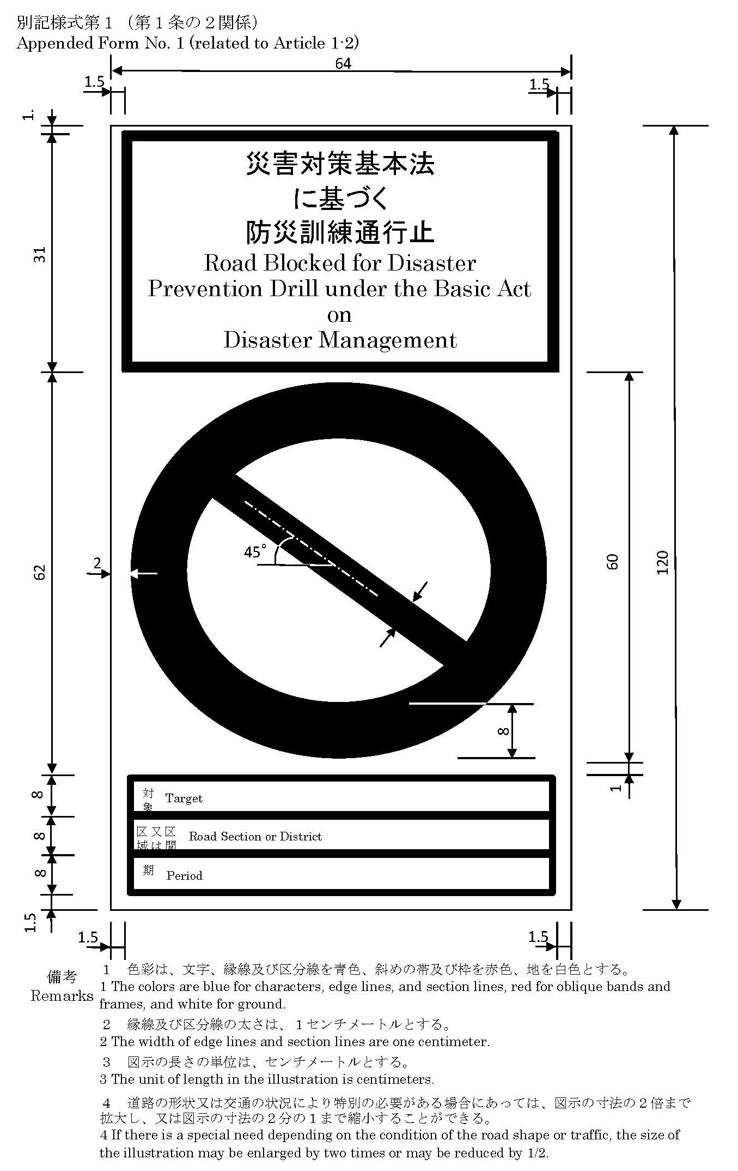
別記様式第２（第５条関係）
Appended Form No. 2 (related to Article 5)
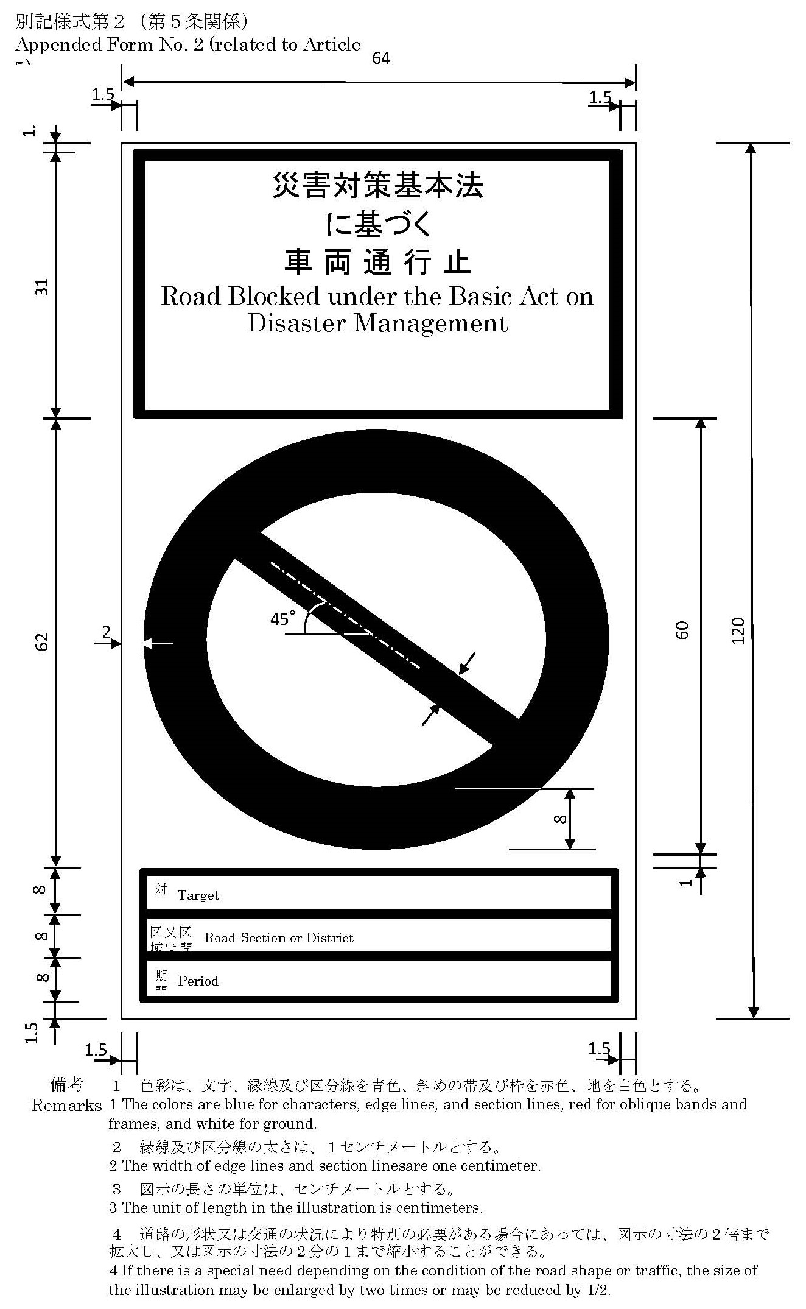
別記様式第３（第６条関係）
Appended Form No. 3 (related to Article 6)
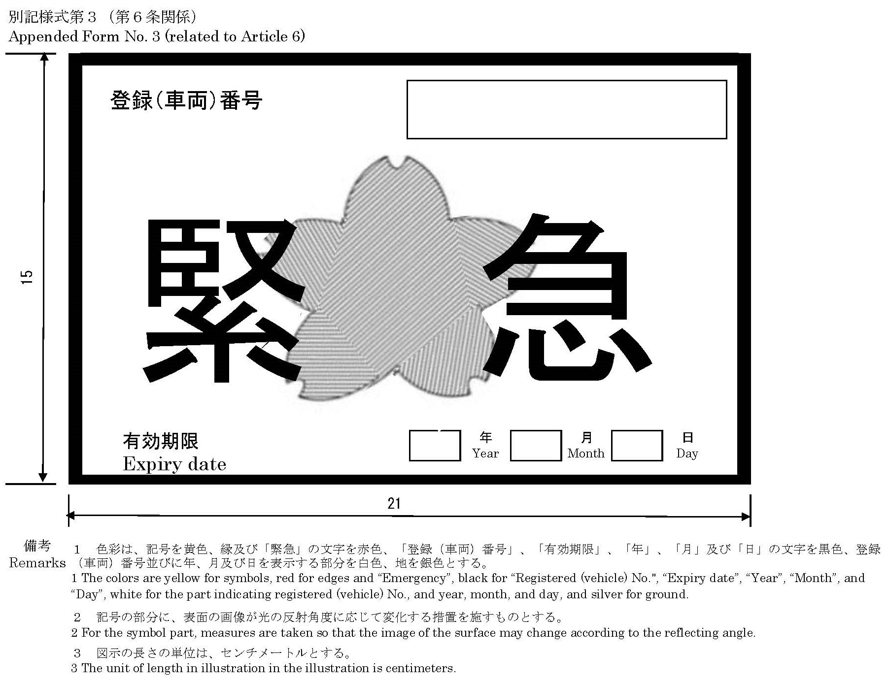
別記様式第４（第６条関係）
Appended Form No. 4 (related to Article 6)
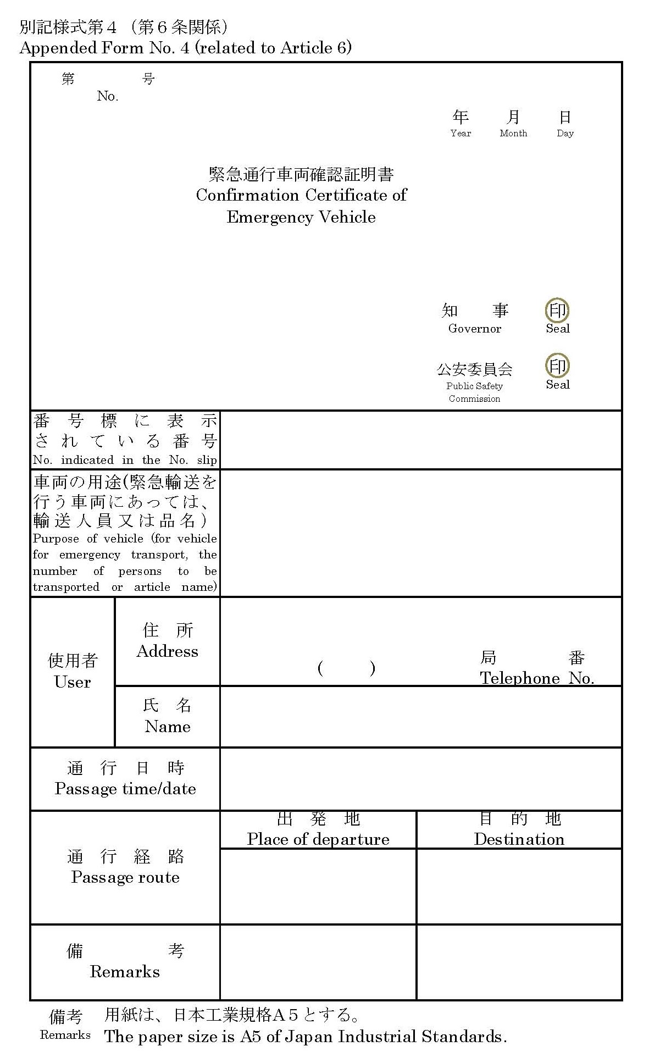
別記様式第５（第７条関係）
Appended Form No. 5 (related to Article 7)
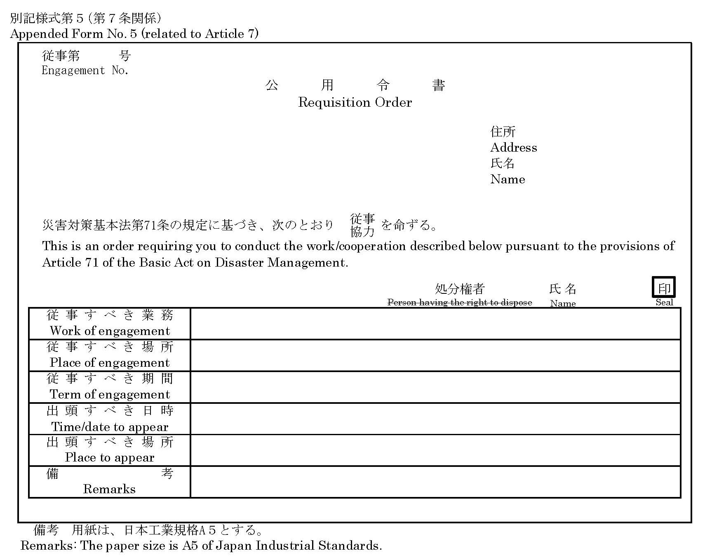
別記様式第６（第７条関係）
Appended Form No. 6 (related to Article 7)
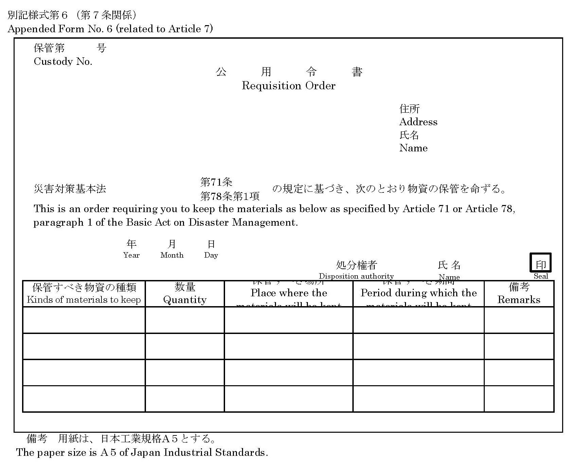
別記様式第７（第７条関係）
Appended Form No. 7 (related to Article 7)
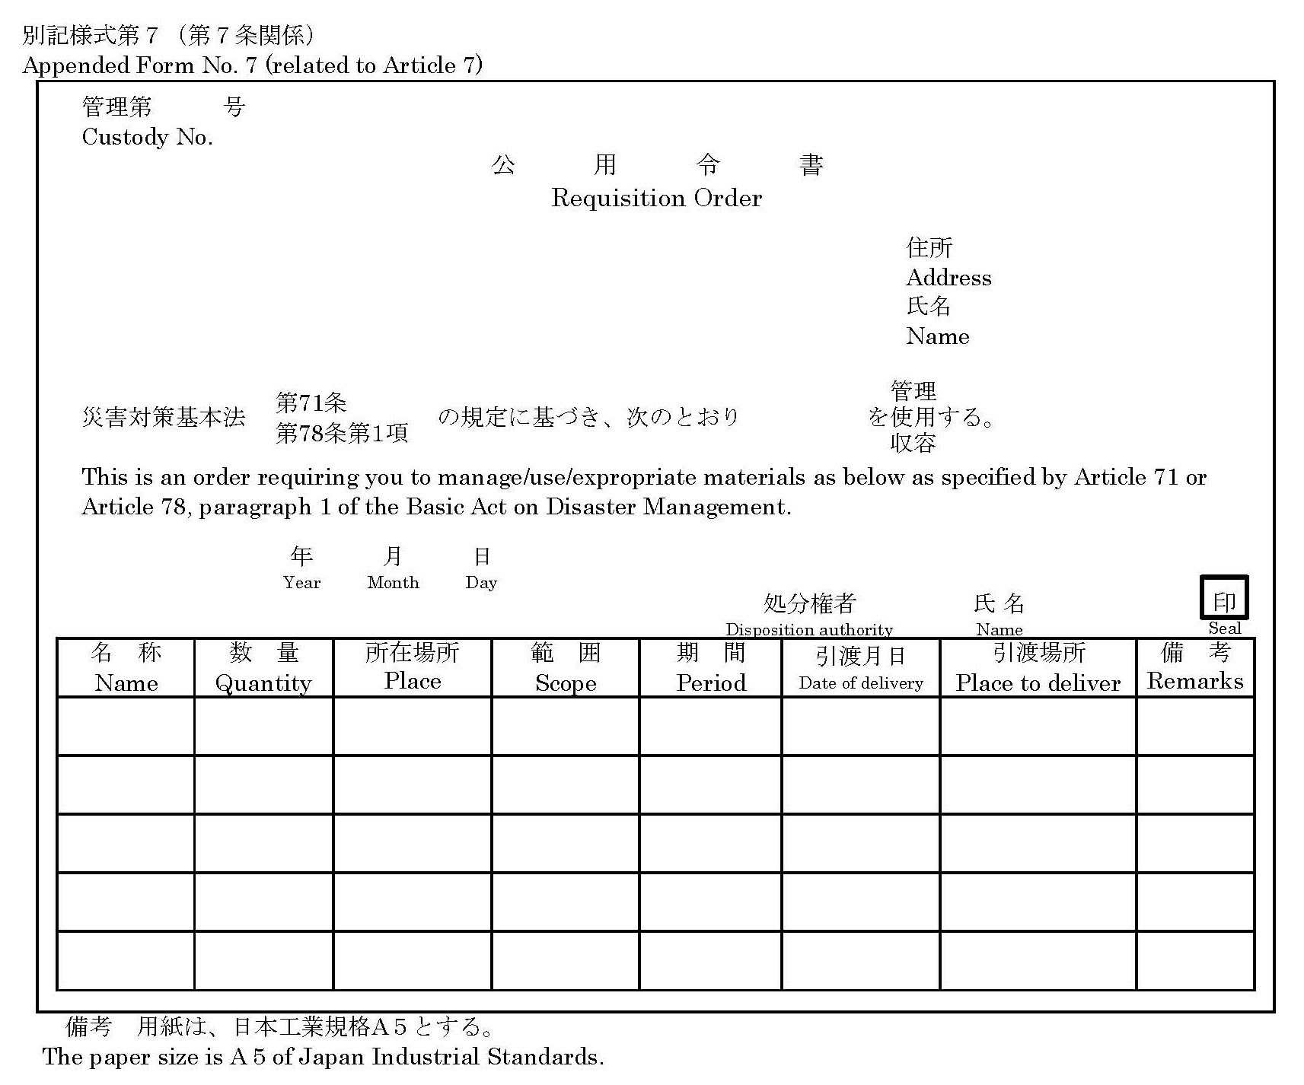
別記様式第８（第７条関係）
Appended Form No. 8 (related to Article 7)
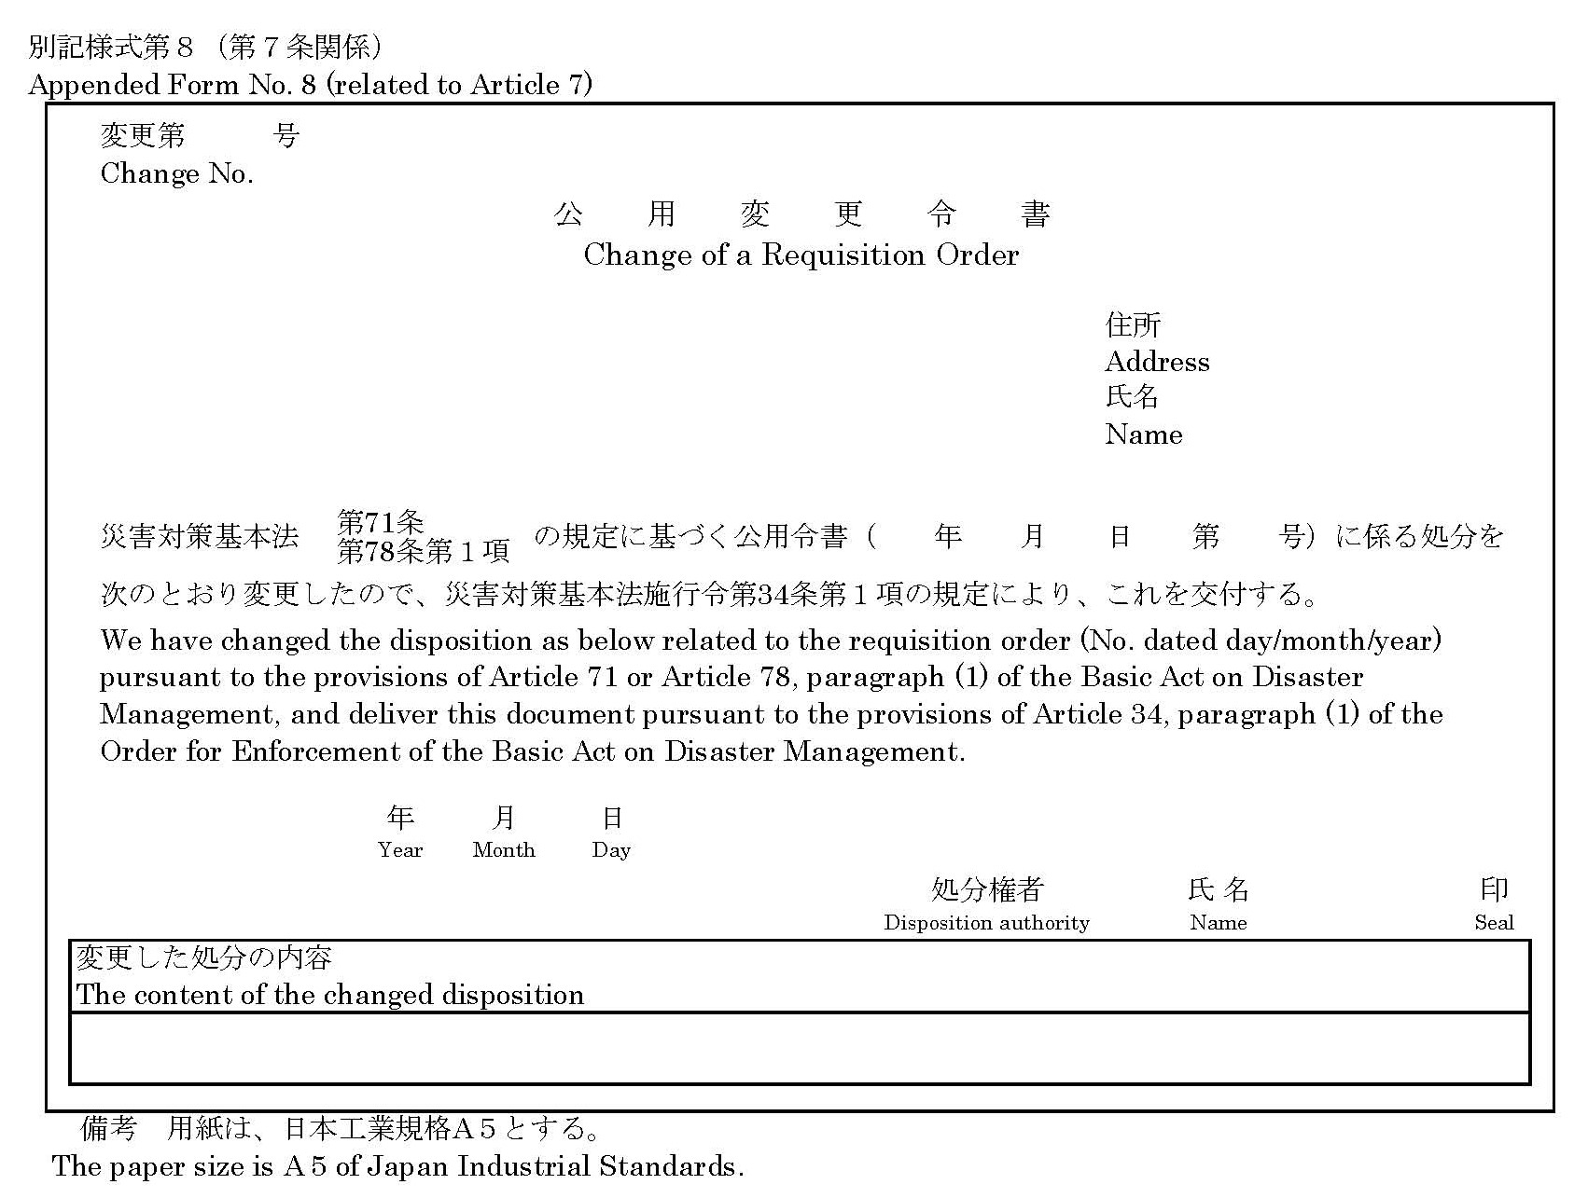
別記様式第９（第７条関係）
Appended Form No. 9 (related to Article 7)
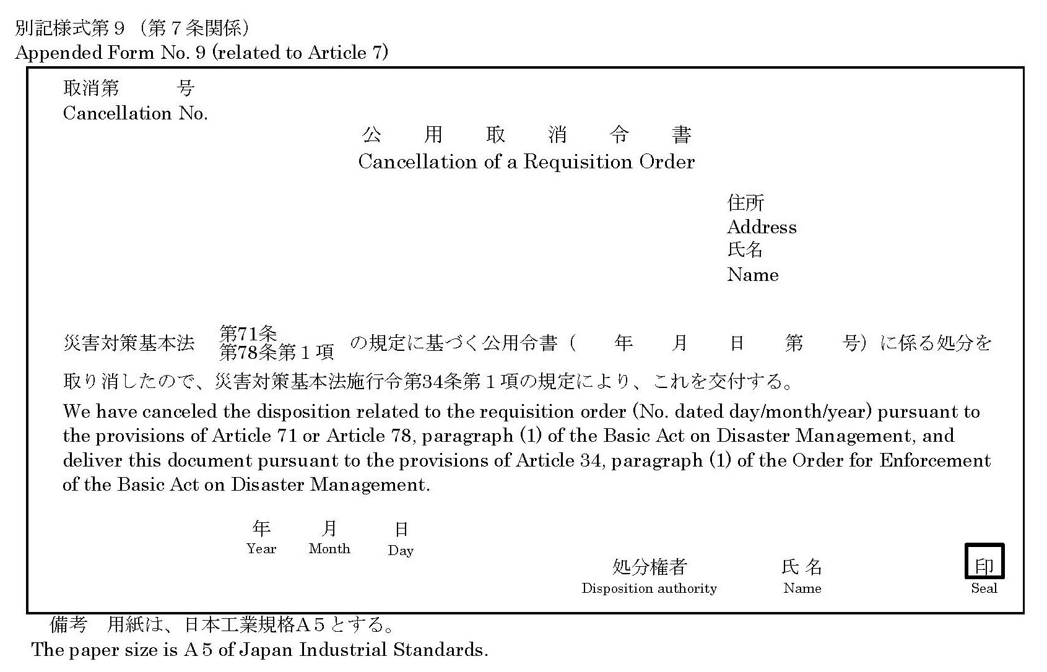
別記様式第１０（第９条関係）
Appended Form No. 10 (related to Article 9)
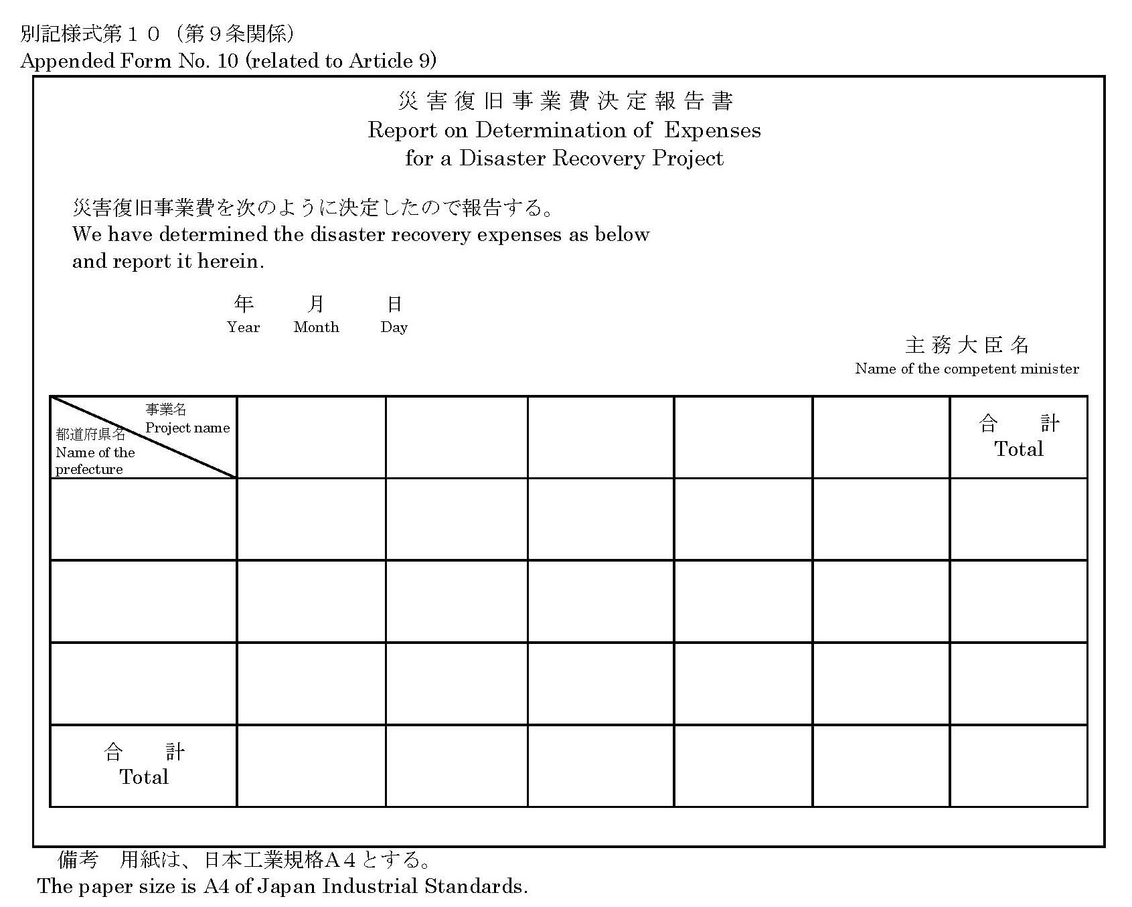
別記様式第１１（第９条関係）
Appended Form No. 11 (related to Article 9)
